
Gospel OAk School – E-zine WE 26th APRIL 2024

It’s been a great week for celebrating the talents and achievements of our students with so
many different activities taking place. Tuesday, Wednesday and Thursday have seen students
from all year groups give fabulous performances in Matilda across both evening and matinee
showings; a huge well done to the cast and crew, and our fantastic Performing Arts’ staff who
have worked so hard to make this happen. Thank you, too, to the many parents, carers, family
members, friends, and other members of our community who have come in to watch and enjoy.
Our Year 11 GCSE Photographers have had their practical exam, and our Year 11 GCSE PE students
took part in their practical moderation; we hope that these experiences were positive. Year 10
geographers have supported our assembly this week on the theme of ‘Earth Day’. Our SEND team also welcomed in many parents and carers to discuss individual needs during their Coffee Morning, and, as part of this, also met with a number of our new Year 7s from September and their families to support transition.

Year 10 and 12 mock exams begin on Monday; Mr Wilson and the Year 10 team have ‘walked through’ all of the exam processes with Year 10 students as this will be their first experience of a major exam series. If you have a child in Year 10 and/or Year 12, please do ensure that they are continuing with their revision and preparation and referring to the materials provided by school to support their preparation. As referred to previously, Year 7, 8 and 9 will be having assessments in English, Maths, Science, History, Geography and MFL in the coming weeks, and a further more detailed letter will follow; these assessments are being sat by all students in the Central Region Schools’ Trust in these year groups. Your child should have started their preparation for these assessments, and should ask their class teacher if they have any questions at this stage. Information about the Year 8 Parents’ and Carers’ Evening on Wednesday 1st May has been sent; as always, please contact us if you are experiencing any difficulties with booking appointments or have any questions about the evening.

Thank you to parents and carers for reinforcing our expectations around uniform, punctuality, attendance, arrival and leaving school and behaviour in the Restaurant and Bistro; the vast majority of students continue to meet those expectations and support – as necessary, sanctions – are in place to help where needed. If you have questions, or have any feedback for us, please use Gospel Oak School - Contact Us to get in touch with any members of our school staff.
Year 11 – BTEC Music

Please note that there is an external exam on Friday 3rd May at 9am for Year 11 BTEC Music students; this is their Component Three exam. Students should arrive at school as normal, and the exam is sat in full exam conditions. As always, students are required to wear full school uniform for their exam and arrive at the restaurant during tutor. The exam itself with take place in S6.

Upcoming Dates

Wednesday 1st May – Year 8 Parents’ Evening

Wednesday 8th May – John Tomsett Maths Visit

Wednesday 8th May – Parent / Carer Forum

Assembly Themes

Assembly focus this week was National Earth Day.

w/c 29/04 - Local & Community History Month

w/c 06/05 - School Values

Please take the time to talk to your child about what they have learnt in Assembly.

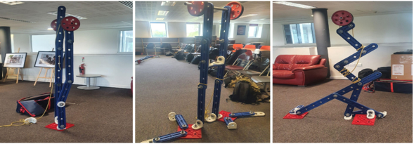
Royal Navy Visit

The esteemed Royal Navy outreach team visited Gospel Oak this week to collaborate with some of our Year 9 students on various STEM (science, technology, engineering, and mathematics) activities. During their visit, they discussed the values of teamwork, leadership, and self-discipline.

As part of the program, 100 students completed an engineering challenge where they constructed a telecommunications tower designed to withstand hurricane forces up to grade 8.

Students also had the opportunity to engage in a question-and-answer session with the team, during which they learned about the crucial humanitarian work conducted by the Navy and Marines worldwide.

Gospel OAk School – E-zine WE 26th APRIL 2024

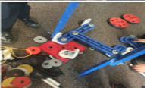
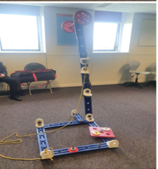



Gospel OAk School – E-zine WE 26th APRIL 2024

Updated Year 10 Mock Examination Timetable:

Y10 Mock Exam Timetable – Monday 29th April– Friday 10th May 2024
All exams in the Sports Hall unless stated

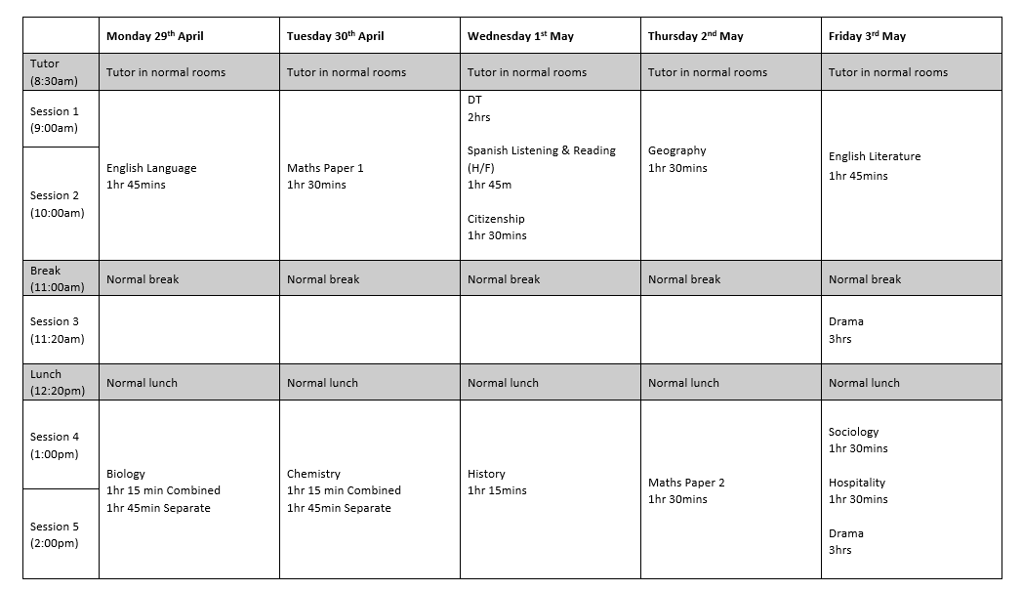

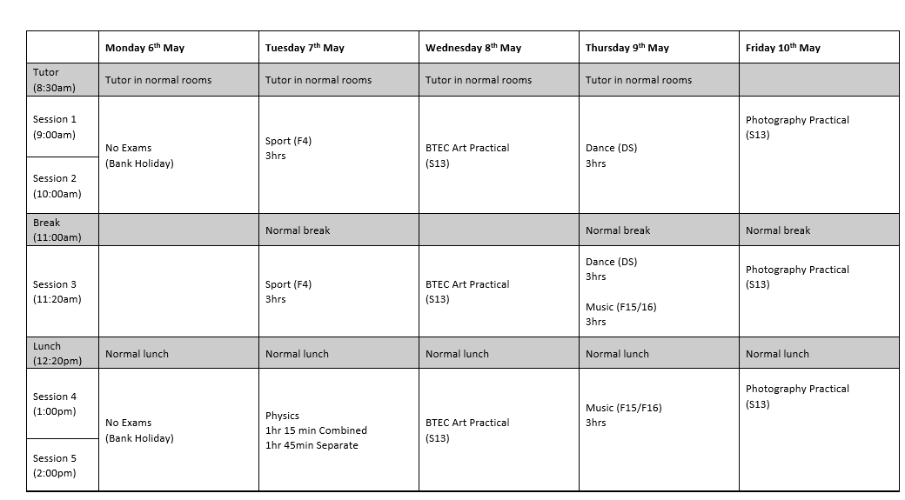

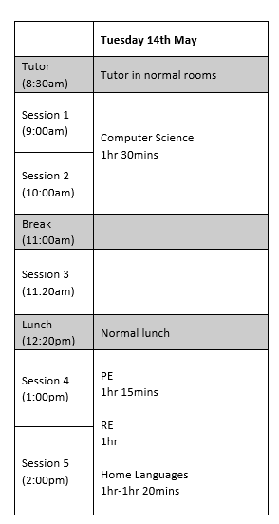
Gospel OAk School – E-zine WE 26th APRIL 2024

Y12 Mock Exam Timetable – Monday 29th April– Tuesday 7th May 2024
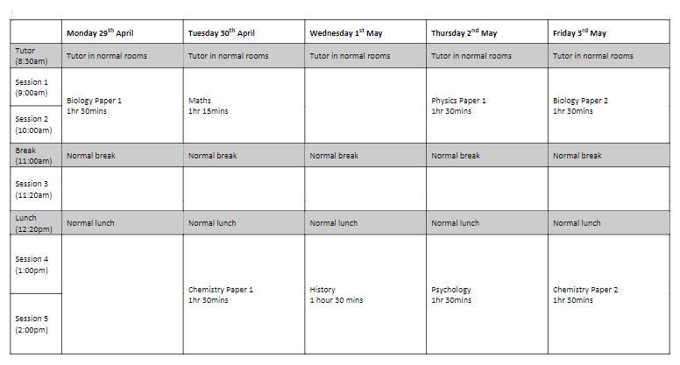
All exams in the Sports Hall unless stated

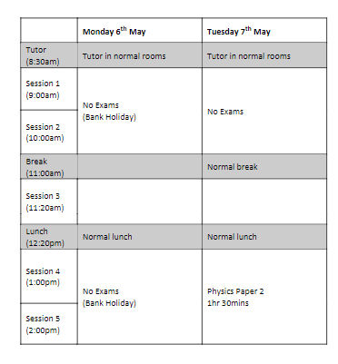

Gospel OAk School – E-zine WE 26th April 2024
 |  |  | Gospel Oak School  Bilston Road  Gospel Oak  Tipton  West Midlands  DY4 0BZ  T 0121 556 1351  F 0121 506 7833  W www.gospeloakschool.co.uk
22nd April 2024 |  |  | Our Ref: MUD/MFA/271  Your Ref:
Dear Parent/Carer,
Re: | Six 4 Schools
I am delighted to inform you that Gospel Oak School has signed up for a new initiative to support families and schools called Six4Schools introduced by the Birmingham Bears.

What is Six4Schools?

Six4Schools is an initiative by Birmingham Bears which offers adult tickets starting at £13 (normally £25) for their T20 matches this summer when using a discount code unique to the school. U5s are always free and 5-15 year olds £5.

Our school will benefit because for every adult ticket sold, the school will receive £6 back. As an example, if we sell 200 adult tickets, we will receive £1200! This is meant to be used to reinvest in the education of the pupils (for example: computer equipment, playground equipment or cricket coaching sessions).

It’s a great opportunity for the school and hopefully a chance for you to enjoy the incredible T20 atmosphere at Edgbaston this summer.

To purchase your tickets, follow the instructions below:

1. visit: Tickets.Edgbaston.com
2. At the top of the page enter this promotional code: GOS24
3. Select the Birmingham Bears fixture you would like to attend this summer (please note the discount only applies to Saturday 8 June and Sunday 14 July fixtures). If you did not enter the promotional code before this can also be done here on the right-hand side of the page.
4. Select the stand in which you would like to purchase your tickets. U16s must be accompanied by an adult and for every 1 adult ticket sold, 5 U16 tickets may be selected.
5. Make your payment using your credit/debit card

You will receive your tickets via email.

It would be fantastic to see as many parents/carers as possible take advantage of this offer to head to Edgbaston this summer to watch some exciting cricket and in the process help us win the interactive board!

Yours sincerely,

Mr M Uddin
PE Department

Gospel OAk School – E-zine WE 26th APRIL 2024

Gospel Oak School
Bilston Road
Gospel Oak
Tipton
West Midlands
DY4 0BZ

T 0121 556 1351
F 0121 506 7833
W www.gospeloakschool.co.uk
25th April 2024 |  |  | Our Ref: SBO.KH.2961  Your Ref:
Dear Parent/Carer,
Re: | Five Fabulous Fridays
We are thrilled to announce a new and exciting initiative at Gospel Oak School – Five Fabulous Fridays. Our goal is to provide our students with enriching, engaging, and enjoyable experiences that go beyond the traditional classroom setting.

Five Fabulous Fridays are a series of afternoons designed to foster connectiveness and belonging across the school. These afternoons will consist of pizza parties, an ice cream van and a drop-down afternoon with a range of exciting activities.

Further to this we will be offering additional incentives every Friday.

- All students who achieve 100% attendance each week, will be given sweets during tutor time.

- From the 10th May 2024, we will be conducting a prize draw every Friday for five weeks. Each day that the student attends, their names will be put in the draw. There will be two winners from each year group. The prize will be a £50 voucher for Nando’s. The student will have to be in school on Friday to claim their prize.

If our Five Fabulous Fridays are successful, we will look to continue these throughout the rest of the Summer term. We will be providing additional information to students during tutor time and assemblies.

Thank you for your ongoing support.

Kind Regards,

Miss S Bott
Vice Principal

Gospel OAk School – E-zine WE 26th APRIL 2024


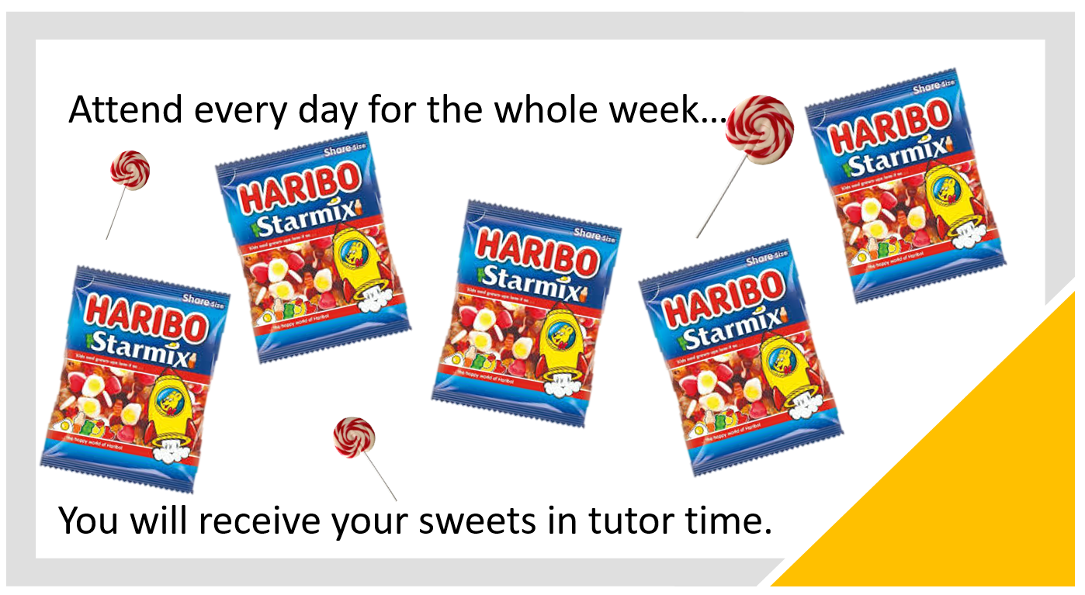





Gospel OAk School – E-zine WE 26th APRIL 2024

