
Year 11 Post 16 Options



Guide for Pupils, Parents and Carers


This guidance booklet has been put together to help you understand the options available to you when you leave school and to inform you of the processes of applying and gaining a place in further education or training. Young people today have more options available for their future than ever before but there are factors that affect them. With an ever-changing workplace landscape, it is even more important for them to make informed choices for their education, training and employment. While for many young people a career may seem a long way off, decisions they make about education and training now may affect their options later on.

- Raising Participation age
- What are my Post 16 Options?
- Types of providers
- How do qualifications compare?
- Where can I find out more? (Local open days)
- Labour Market information
- The Application Process
- Once I know what I want to apply for, what do I do next?
- Further Support
- Personal Statements

1.Raising the Participation Age
From September 2015, young people have been required to stay in education or training up to the age of 19. Gaining more qualifications, recognised by employers will increase your earning power and improve your life chances. We all know that our own and the world economy is changing. Today, more jobs require higher levels of skills than in the past. Young people without qualifications are at a disadvantage. If young people are disadvantaged, then so is our economy as we need to compete with other countries for jobs.

2. Post 16 Options?
Your career starts now. Like a road map there are choices you have to make and pathways that lead you in a particular direction.
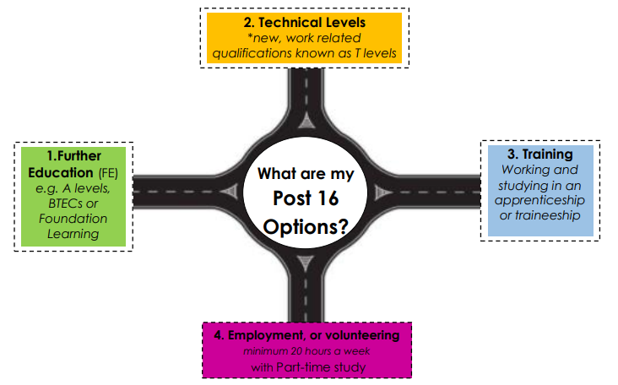

There is no right or wrong pathway. We are all unique with our own set of skills, interests and careers goals. We have to choose what is right for us as individuals.

We are all on our own exciting journey!

Further Education
A Levels Known as Advanced levels are the traditional qualifications offered to 16-19 year olds. They are highly valued by universities and employers and focus on academic subjects.
With the A level reforms many subjects will now be taught as a two-year linear course with exams at the end of the 2nd year. You are usually offered 3 subjects, however, some able pupils may do 4.
There is a wide range of subjects to choose You are usually required to obtain at least 5 GCSEs at grades 4-9 including English and Maths. Some providers require two grade 6s. For some subjects such as Maths and Science you might be required to get at least grade 6 in that GCSE to continue on into the A level. You will need to check with individual providers as to what their entry requirements are, that is why it is best to aim as high as you can to give yourself the best choices.
BTEC
(Business and Technology Education Council) are vocational (job or work-related) qualifications. They’re designed for people interested in a particular sector or industry. These qualifications accommodate the needs of employers as well as allowing progression to university. They provide a more practical, real-world approach to learning alongside a theoretical background. Emphasis is on coursework, on-going assessment, work-based assignments although some include exams. There is also an element of work experience.
There are providers such as Cadbury that offer a hybrid study programme that allow you to do a combination of both A levels and BTEC subjects.
Foundation Learning/Access to Further Education
Are courses for those who have few or no formal qualifications or are unsure about which educational or career route they want to follow. These courses enable you to achieve qualifications whilst keeping your options open. This course can lead onto Level 1 or Level 2 courses or a training programmes along with developing your skills in English and Maths. Some of these courses offer 5 ‘taster’ subjects to help you decide what you want to specialise in after completion.

T Levels - Technical Qualifications
These are a new two-year course (equivalent to three levels). They have been designed by employers to meet the needs of the work place. They have been running since September 2020, digital production, design and development, design, surveying and planning, education. They have also recently added, building services, engineering for construction, healthcare science and Science. Find out more about where you can study them.
https://www.gov.uk/government/publications/introduction-of-t-levels/introduction-of-t-levels
https://www.gov.uk/government/publications/providers-selected-to-deliver-t-levels
Apprenticeships
An Apprenticeship is a real job with contract and training which allows you to earn while you learn, whilst gaining a nationally recognised qualification. Apprenticeships take between one and five years to complete and cover 1500 job roles in a wide range of industries, from engineering to accountancy, public relations to veterinary nursing, law to paramedics. Apprenticeships are now available at degree level and beyond. The current minimum starting wage is £4.15 per hour. This increases the older you get and as you complete the course. The average weekly wage is £170, depending on the company, it can be a lot higher.
Traineeships
A traineeship is an education and training programme with work experience that usually lasts from 6 weeks to 6 months unlocking the great potential of young people by helping them to become ‘work ready’ helping them to secure an apprenticeship or employment.
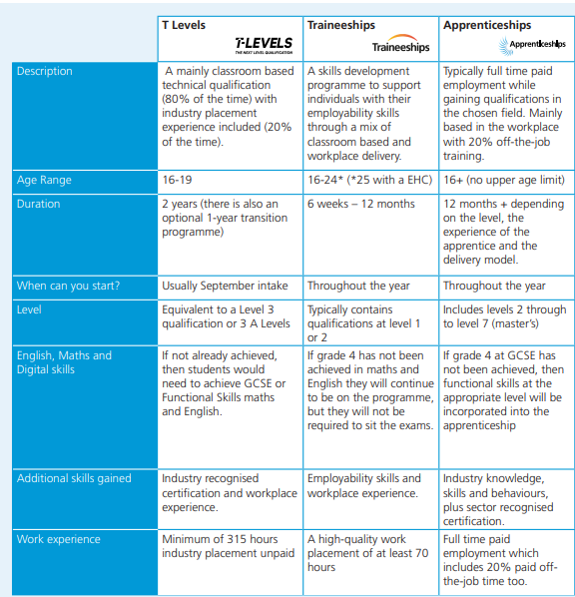
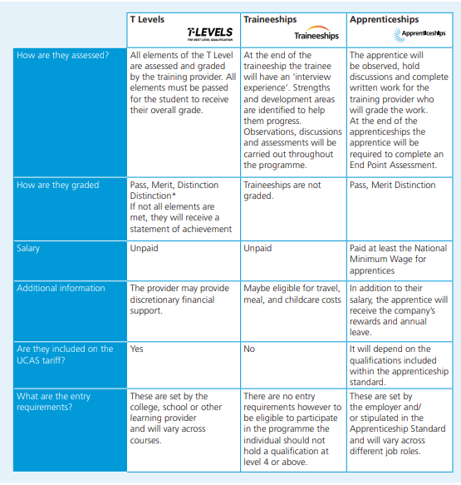

3. Types of Providers

School Sixth Forms
Your Sixth Form experience can really shape your life, these final years of school are an important stepping-stone into further education and life beyond. With exceptionally high results Holyhead sixth form offers a warm and friendly enviroment to achieve. With much smaller class sizes, personal tutors, teachers and support for University applications, work experience and job applications. We offer a range of subjects both A level and BTEC that will support you into the University / Vocation of your choice. If you work better in familiar surroundings and with slightly more structure around you then sixth form is the perfect choice. Our open day is Thursday 24th October 2024 from 6pm - 8pm

Further Education Colleges

Are for people aged 16+, they offer a wide range of courses, some offer both academic (A-levels) and vocational and practical qualifications at all levels (giving you skills and knowledge for a particular industry) Some offer apprenticeship training,you might be studying with people who are a different age to you some have level 4-6 courses to go onto

Sixth Form Colleges

Are for young people aged 16 to 19, they offer a range of courses, usually a large range of A’levels and BTEC diploma qualifications most courses are level 3, some offer a few level 2.

University Technology Centres (UTCs)

Specialist Technology colleges such as Aston University Engineering Academy aims of encouraging young people to study science, technology, engineering and maths.

Training Providers

Training providers are places you would study for your apprenticeship qualification
Some often have a specialist area such as , Engineering / mechanics / customer service and Health and social care.
You often spend 1 day a week with the provider and the remaining time in a work place.
Training providers also support young people with life skills into the world of work and adult life covering things such as mental health, healthy lifestyles, finance, employability and environmental sustainability

4. How do qualifications compare?
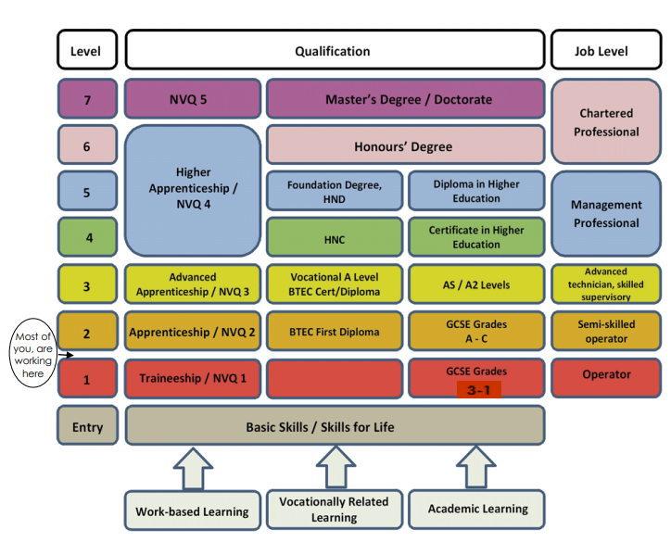
Please note:
GCSE grades have now changed to 1-9

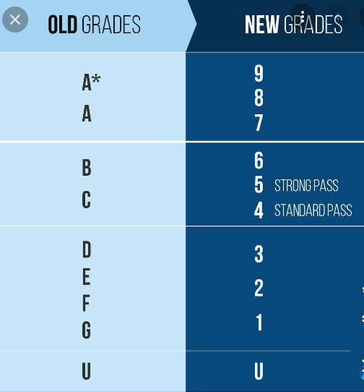

5. Where can I find out more?
Attend the Open Day events
Sign up to the providers’ open days to see their facilities and speak to the specialist subject tutors. This will help you decide if you want to apply for a place. Often you will need to preregister on the providers’ website. See the list below for some dates and times.
Open Days 2023 / 2024 (Please note you may have missed some of the current open days but more will be added to the websites over the next few weeks.

College | Open Event | Time | Contact Details
Access Creative | Saturday 12 October 2024  Check website for further dates. | 11am – 2pm | 0121 281 5711  www.accesscreative.ac.uk
Birmingham Metropolitan College | Saturday 19 October 2024  Wednesday 13 November 2024  Wednesday 26 February 2025  Saturday 14 June 2025 | 10am – 1pm  4pm – 7pm  4pm – 7pm  10am – 1pm | 0121 446 4545  www.bmetc.ac.uk
City of Wolverhampton College  (check which campus you need to attend for the course(s) you want) | Wednesday 9 October 2024  Saturday 11 January 2025  Wednesday 30 April 2025  Saturday 14 June 2025 | 4pm – 7pm  10am – 2pm  4pm – 7pm  10am – 2pm | 01902 836 000  www.wolvcoll.ac.uk
Dudley College | Saturday 12 October 2024  Saturday 11 January 2025  Saturday 8 March 2025  Wednesday 11 June 2025 | 10am – 2pm  10am – 2pm  10am – 2pm  4pm – 7pm | 01384 363000  www.dudleycol.ac.uk
Halesowen College | Saturday 12 October 2024  Wednesday 6 November 2024  Saturday 18 January 2025  Wednesday 30 April 2025 | 10am – 4pm  4pm – 7pm  10am – 2pm  6pm – 8pm | 0121 602 7777  www.halesowen.ac.uk
King Edward VI 6th Form College, Stourbridge | Thursday 17 October 2024  Saturday 19 October 2024 | 5pm – 9pm  9am – 3pm | 01384 398100  www.kedst.ac.uk
Sandwell College  (Central St Michaels, New Square for A level & Young Professionals Academy) | Thursday 10 October 2024  Saturday 12 October 2024  Thursday 14 November 2024  Saturday 16 November 2024  Tuesday 14 January 2025  Saturday 18 January 2025  Tuesday 26 February 2025  Thursday 12 June 2025  Saturday 14 June 2025 | 4pm – 7pm  11am –3pm  4pm – 7pm  11am – 3pm  4pm – 7pm  11am – 3pm  4pm – 7pm  4pm – 7pm  11am – 3pm | 0800 622 006  (course enquiries)  0121 667 5000  (switchboard)  0121 667 5100  (Central St Michaels)  www.sandwell.ac.uk  www.centralstmichaels.ac.uk
South and City College Birmingham (including Bournville College) | Thursday 26 September 2024  Thursday 21 November 2024  Saturday 25 January 2025  Wednesday 19 March 2025  Saturday 21 June 2025 | 4pm – 7pm  4pm – 7pm  10am – 3pm  4pm – 7pm  10am – 3pm | 0800 111 6311  www.sccb.ac.uk
South Staffordshire College  (Rodbaston campus) | Saturday 12 October 2024  Check website for further dates. | 10am – 1pm | 0300 456 2424  www.southstaffs.ac.uk
University College Birmingham | Saturday 19 October 2024  Check website for further dates. | 10am – 2.30pm | 0121 604 1000  www.ucb.ac.uk
Walsall College | Thursday 10 October 2024  Tuesday 26 November 2024  Saturday 25 January 2025  Wednesday 26 March 2025  Saturday 21 June 2025 | 4pm – 8pm  4pm – 8pm  10am – 2pm  4pm – 7pm  10am – 2pm | 01922 657000  www.walsallcollege.ac.uk

Sixth Form | Opening Evenings | Time | Contact Details
George Salter Academy | tbc |  | 0121 553 4665  www.georgesalter.com
Gospel Oak School | Thursday 24 October 2024 | 6pm – 8pm | 0121 556 1351  www.gospeloakschool.co.uk
Holly Lodge High School | Thursday 3 October 2024 | 5pm – 7pm | 0121 558 0691  www.holly-lodge.org
Ormiston Forge Academy | tbc |  | 01384 566 598  www.ormistonforgeacademy.co.uk
Phoenix Collegiate Academy | Thursday 26 September 2024 | 4pm – 8pm | 0121 588 8384  www.phoenixcollegiate.net
Q3 Academy  Great Barr | tbc |  | 0121 358 6186  www.q3academy.org.uk
Q3 Academy Tipton | tbc |  | 0121 521 1540  www.q3tipton.org.uk
Sandwell Academy | Saturday 25 January 2025  Saturday 1 March 2025 |  | 0121 525 1700  www.sandwellacademy.com
Shireland Biomedical UTC | tbc |  | 0121 828 1123  www.sbmutc.org.uk
Shireland Collegiate Academy | tbc |  | 0121 558 8086  www.collegiateacademy.co.uk
Stuart Bathurst Catholic High School | tbc |  | 0121 556 1488  www.stuart-bathurst.org.uk
Wood Green Academy | Wednesday 2 October 2024  (Deadline for applications 25/10/24) | 5.30pm | 0121 556 4131  www.woodgreenacademy.co.uk

Research providers’ websites and collect prospectuses
Gather as much information about as many colleges you are interested in. Try to find out their latest results and the post 18 destinations of their students to gage how successful they are. You can compare their attainment on this website. https://www.compare-schoolperformance.service.gov.uk/compare-schools?for=16to18

Is the course right for me?
UCAS offer information and guidance and you will be able to view entry requirements for each University and course (This is important in choosing you’re A level/Btecs)
There are some good videos that explain the different types of courses and a short 4 question quiz looking at your own learning styles and preferences. https://www.ucas.com/ucas/16-18- choices/getting-started/what-are-my-options/what-qualifications-are-there-for-16-18

Birmingham Careers Service 1 to 1 Careers Meeting :
All year 11 pupils are offered a One hour careers guidance meeting, please ensure you attend this you will be getting time in tutor. This is an opportunity to receive impartial Information, Advice and guidance (IAG)about careers, colleges, apprenticeships, universities or anything you may need support with. Following this you will be given a copy of your personalised Careers Action Plan as a record of your discussion and to help you understand what your next steps are.

6. Labour Market Information
https://bep.education/birmingham-careers-hub/lmi/
Labour market information can help young people to make informed decisions about their future study and career choices. Labour market information tells you about what is happening in the job market at national, regional and local levels and includes information about jobs and salaries, what skills employers are looking for in different industrial sectors, conditions, communities and future trends.
The Birmingham Education partnership (LMI) toolkit is a free, easy to use platform, This platform specifically detailed localities. This toolkit is unique in its ability to define comprehensive LMI across Birmingham.
7. The Application Process
Do not worry if you don’t have a clear idea of what job you want to do when you are older, not knowing is good for keeping your options open to lots of different careers. Think about these questions below…

What do you enjoy? Many of you will be studying these subjects for the next 2 years, so choosing ones you actually enjoy will keep you motivated and help you achieve the best grades possible. Unless the subject is an entry requirement for your degree, or necessary to other future plans you may have, there’s no point signing up for it if you don’t look forward to lessons
What are my strengths and recommendations. Which subjects do you excel in and why? Talking to your teachers will give you an accurate idea of where your strengths and weaknesses lie, and guide you toward the subjects that may suit you better than others.
Conversations Speak to people who know you well such as parents and teachers.
Complete some virtual Work Experience or Insight Days To help you better understand what a career sector is all about try out some virtual sessions to ask questions and see what would be involved. Ideally everyone should do this before September 2021 they move into post 16 provision. Such as
https://www.springpod.co.uk/find-work-experience/
https://medicmentor.co.uk/university-hospitals-birmingham-trust-virtual-work-experience/
https://www.speakersforschools.org/experience-2/vwex/
https://barclayslifeskills.com/i-want-virtual-work-experience/school/virtual-work-experience
Check out the 5 stories of work experience with Stacey Dooley. www.bbc.co.uk/bitesize/articles
Research Take a look at the syllabus or course content for the subjects you are considering, especially if they were not available to you at GCSE level, such as Politics or Psychology. Some students take subjects they think will interest them, but quickly become disappointed when they find it’s not what they were expecting. Also see the Cadbury Career Pathways
Future Career Plans If you’re considering going to university you need to check the entry requirements for the course(s) you are considering. There are a significant number of subjects where at least one particular A level is compulsory. See www.ucas.com for higher education degrees and courses. E.g. Nursing degrees usually require an A level or Level 3 BTEC in a science subject.

Not going to university? Try to pick subjects that will be valuable to potential employers, and useful in the real world. For example, Mathematics has applications in many industries, as does Biology, Economics and Business Studies. www.notgoingtouni.co.uk
“Soft” subjects Some top universities in the UK have A level “blacklists”, made up of subjects they feel do not prepare students for a degree as well as more traditional ones such as Chemistry, Mathematics and History. If you are planning to apply to a prestigious or “red brick” university, make sure you’re not going to put yourself at a disadvantage by choosing an A level in Media Studies, Photography or Sociology. Russell Group universities recommend you choose at least 2 traditional subjects to ensure you will be considered by their admissions tutors. If you’re still uncertain, phone or email the university admissions team and ask for their advice.

Subject Tasters Some of the colleges are offering taster sessions. Try as many as you want to give you a deeper insight into the different subjects.

Remember you should never feel pressured into a subject you don’t feel comfortable with. You’re the one that has to complete the exams, or practical work for it, always pick subjects you feel confident about.

8. Once I know what I want to apply for, what do I do next?
Application Forms Once you know where you want to apply to, you need to complete your online application forms on the provider’s websites. You should submit a minimum of 2 applications giving you a first choice and a back-up option. You can submit more but remember you will need to attend all of the interviews. Support with applications will be available during Monday lunchtimes in the library.
Personal Statements
Some application forms ask for a personal statement or further detailed information about you. Please see the template included of what you could include.
References
Form Tutors will be completing your references in November / December. Your punctuality, attendance, predicted grades will be noted as well as comments on your character and attitude to learning. Please note most colleges will be expecting you to have at least 95% attendance or higher, unless there has been a genuine reason for your absence
Deadlines
Applications should ideally be submitted by the end of December. Post 16 providers do have various deadline dates please be aware of this so you do not leave it too late. You can make adjustments to your subject choices if necessary in writing an email to the provider to explain your reason why
Confirmation
You should receive an email, letter or text from the post 16 provider to say they have received your application. If you do not receive any confirmation you may need to check it has been received. The provider will then usually request a reference form from the school.
Interviews
Some colleges will start their interview process quickly and some in the new year, depending on how soon you apply. If this is during school time you must show the letter/text/email to reception when you sign in or out of school.

9. Further Support
The 16 to 19 BursaryFund
The 16 to 19 Bursary Fund provides financial support to help students overcome specific financial barriers to participation so they can remain in education. There are 2 types of 16 to 19 bursaries:
• Bursaries for defined vulnerable groups of up to £1,200 a year
• Discretionary bursaries which institutions award to meet individual needs, for example, help with the cost of transport, meals, books, lCT and equipment. The criteria includes those who are:
• In care
• Care leavers
• Receiving Income Support, or Universal Credit because they are financially supporting themselves or financially supporting themselves and someone who is dependent on them and living with them such as a child or partner
• Receiving Disability Living Allowance or Personal Independence Payments in their own right as well as Employment and Support Allowance or Universal Credit in their own right
Check with the providers of what they might be able to support you with.

- Applications for college – How to write a Personal Statement
Your personal statement is a way of conveying your reasons for wanting to study at a particular college, do a type of course, and to also demonstrate your ability to complete the course successfully. The application process for college can be very competitive and a strong personal statement is crucial to ensure your chances of success. There is no single, right way of writing a personal statement. However below are a few suggestions on what to include (you may want to use some or all of the points below to help structure your personal statement). Please note: Each college may provide its own guidelines on what to include in your personal statement (this might include a word or page limit, or specific content requirement), but please check with the college/s you are applying to
• Introduction Here you could outline:
- Who are you and/or where are you currently studying
- What are you applying for (e.g. English literature, bricklaying, childcare)
- Your reasons for wanting to study your chosen subjects
- Your reasons for wanting to study at that particular college (e.g. what makes that college standout for you?)
You should demonstrate enthusiasm for your chosen subject/s, course type and college, and show that you have a good understanding of the subject area and college you are applying to. Failure to personalise your personal statement to a college and course could suggest you are not serious about your post 16 college choices.
- Talk about your school subjects In this section you should discuss your strengths and key skills and relate them to what you are applying for. This will demonstrate that you are capable of accomplishing the course/s successfully.
- Discuss any position of responsibility you may have had This might include being a Student Leader, Prefect, Peer Mentor etc.
- Talk about work experience including non-GCSE activities in school This could include what you did do for your Year 10 work experience. Do you have a part-time job? Do you volunteer? What skills, knowledge, and experience have you developed from these experiences? How useful were these experiences? You could also include assisting at open evenings, taking part in drama productions, school fundraising events, projects, sports teams, meetings etc.
- Talk about extra-curricular activities outside of school This could include any hobbies or interests (rock climbing, keeping fit, youth club etc.). You could also talk about any additional certificates/awards you have achieved such as Duke of Edinburgh, sports achievements, music awards (e.g. Grade 4 Piano) etc. It can also include any charity/fundraising activities you have taken part in or organised outside of school. Don’t forget to mention if you are signed up to do the NCS (National Citizenship Service) at the end of Year 11.
- Write about your plans for the future In this section you could write about what you would like to do in the future and why; explaining how your chosen subject/s can help you achieve this

Useful sentence starters for writing a personal statement:
I am a year 11 student at…..School studying GCSE in… | My favourite subjects are… | I am currently
My strengths are… | I am proud of… | I enjoy…
My greatest achievement(s) is/are | I plan to… | I hope to…
I intend to… | This year… | While at school…
Outside of school… | Along side my school work I… | Last term I…
Recently… | During the summer… | I worked hard to…
To develop my skills in… | To achieve… | To improve…
I find / have found……Challenging / difficult | In addition,… | Furthermore…

What is a Skill? A skill is something that can be developed or improved upon through training or practice. This could be in a work place or education setting.

Skills you can include in your personal statement
Team work | Verbal / oral communication | Good listener
organisation | Time management | ICT skills
Planning | Reading | Written communication
Analysing | Presenting | Researching
Problem solving | Leadership | Decision Making

What is a Quality? A quality is part of your personality. It often describes the way you interact with others or behave
Qualities you can include in your personal statement
Adaptability | Flexibility | Proactive approach
Reliability | Caring/friendly | Inquisitive
Punctual | Patient | Polite
Responsible | Dedicated | Confident
Positive | Ambitious | Conscientious
Honest | Hard working / dilligent | Helpful
Thoughtful | Proactive | Adventurous

Useful websites The following websites provide further information on how to write a personal statement; including top tips, Dos and Don’ts, and example personal statements:
• www.thestudentroom.co.uk/content.php?r=15927-sixth-form-college-entrance-personal-statements
• www.focuspoint.org.uk/s4-6/applying-to-college/your-college-personal-statement

Example personal statements Over the page, you will find an example of a personal statement. Consider things such as: is the content clear and informative?
Is the content free from spelling and/or grammatical errors? Do you know what the applicants want to study at college and why? (Reviewing example personal statements can help you to develop your own.) A number of establishments allow you to bullet point your personal statement so don’t be afraid to do that if it helps.

Example .
I am interested in joining xxxxxxxxxxxxxxxx Sixth Form College because I want to gain A-levels and maybe advance into university. I think that by going to the xxxxxxxxxxxxxxxx sixth form I will gain these A-levels and advance to university.
I have good attendance, punctuality, behaviour, homework and classwork. I have good skills in communicating which, I developed during work experience. I also have skills in teamwork and have strong self-confidence, also which I gained from work experience. At work experience I learned more about computers and how they work, also I learned more about architecture and using Information technology to produce architectural drawings. I have good business, computer and mathematics knowledge, which I hope to gain A-levels in. I am very pleased with gaining an A grade in both Information technology and business studies also I am very pleased with the A grade in Graphics, also a subject which I hope to study at A-level. I have recently done my mock GCSE's and I have learned that a lot of preparation has to be done for success in these exams. I also have to prepare for my mock interview. Also workload in school has been increasing in both class-work and coursework; I have learned that if we do not meet the deadlines then workload increases even more! In my spare time I go out with my friends and play football and cricket. I used to play cricket for a club and here I met new people, where I gained communication skills and increased my self-confidence I am also a season ticket holder for Wolverhampton Wanderers and I have met new people at the ground, and also by needing to communicate with people at the ticket office. I like listening to music and playing a lot of sports. I sometimes help my uncle with decorating and I meet new people and gain more decorating skills At college I hope to gain three A-levels in maths, physics, graphics and business studies. From there I hope to go to university and do a course in architecture, interior design or designing cars. I hope to then work in architecture or for an automobile firm.

