
A Level Biology
Bridging Course
Welcome to A Level Biology!
Biology plays an important role in the understanding of complex forms of life involving humans, animals, and plants. The subject helps individuals understand the interaction between humanity and the world. It also develops interests in the lives of living organisms to preserve them.


In Biology will you use your Maths, Chemistry and Physics knowledge with your English essay writing skills. It is truly an all-round subject which will stretch and challenge you.

This step up to A’ Level course is designed to get you thinking, summarising, and writing like a Biologist.
A level Biology will use your knowledge from GCSE and build on this to help you understand new and more demanding ideas. The areas we will look at in this booklet are:
- DNA & the Genetic Code
- Biological Molecules
- Exchange & transport

As well as looking at the meanings of keywords, creating mind maps, summaries, and explanations you will be expected to write essays. This is to prepare you for the 25-mark essay question in the final exam. All work will be used in you’re a level classes so make sure you print / save a copy for your folder.

For each activity you can use your revision guide and the resources indicated.



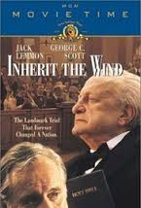
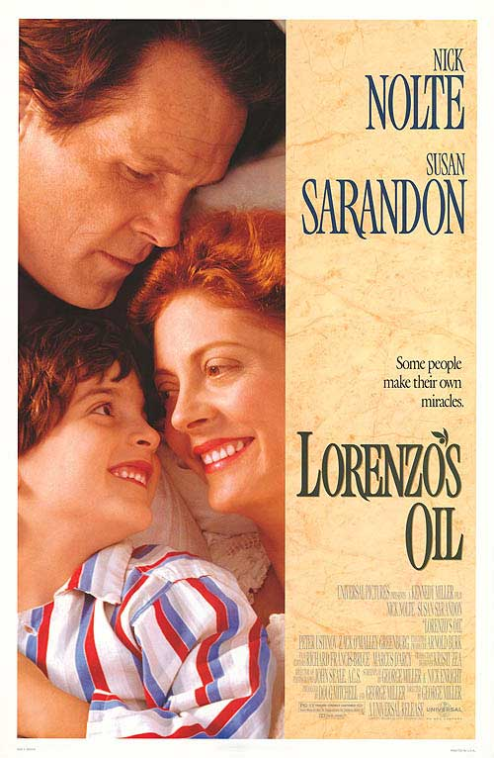
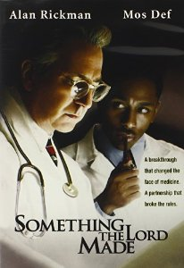
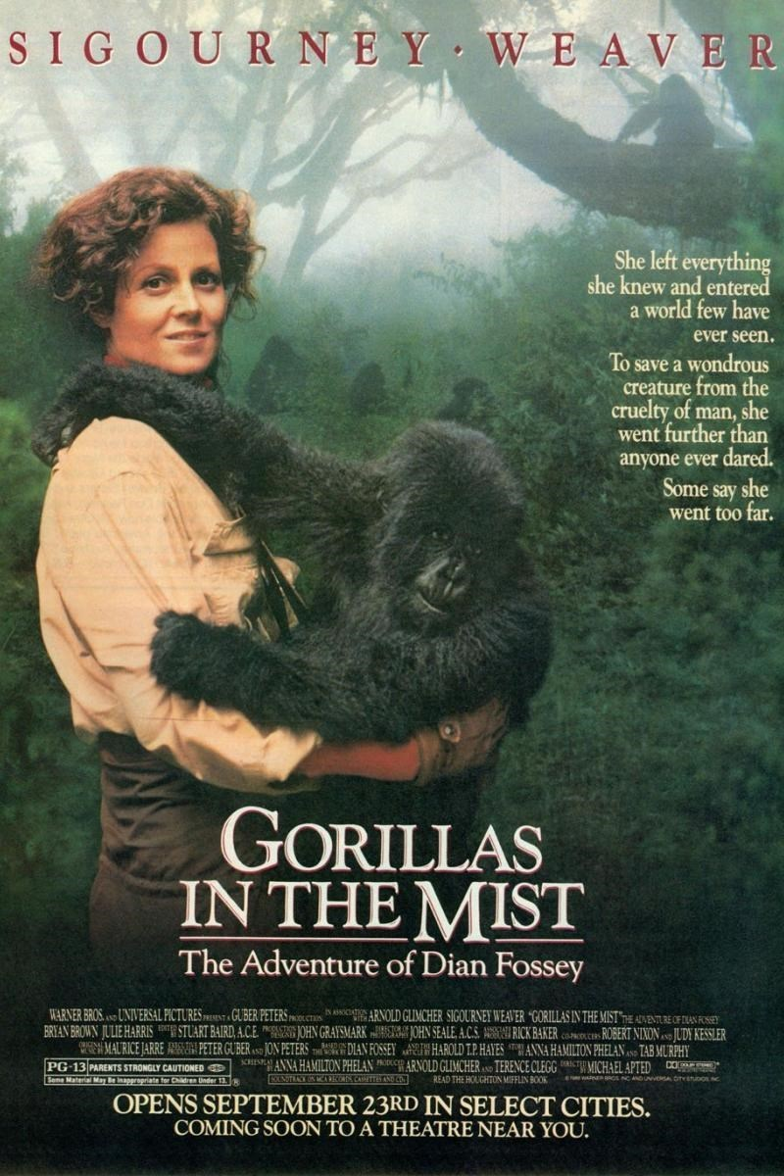
Something the Lord Made (2004)
Professor Snape (the late great Alan Rickman) in a very different role. The film tells the story of the scientists at the cutting edge of early heart surgery as well as issues surrounding racism at the time.
Everyone loves a good story, and everyone loves some great science. Here are some of the picks of the best films based on real life scientists and discoveries. You won’t find Jurassic Park on this list; we’ve looked back over the last 50 years to give you our top 5 films you might not have seen before.
Inherit The Wind (1960)
Great if you can find it. Based on a real life trial of a teacher accused of the crime of teaching Darwinian evolution in school in America. Does the debate rumble on today?
Lorenzo’s Oil (1992)
Based on a true story. A young child suffers from an autoimmune disease. The parents research and challenge doctors to develop a new cure for his disease.
Gorillas in the Mist (1988)
An absolute classic that retells the true story of the life and work of Dian Fossey and her work studying and protecting mountain gorillas from poachers and habitat loss. A tear jerker.
Andromeda Strain (1971)
Science fiction by the great thriller writer Michael Cricthon (he of Jurassic Park fame). Humans begin dying when an alien microbe arrives on Earth.
There are some great TV series and box sets available too, you might want to check out: Blue Planet, Planet Earth, The Ascent of Man, Catastrophe, Frozen Planet, Life Story, The Hunt, and Monsoon.
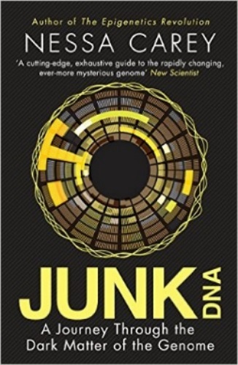
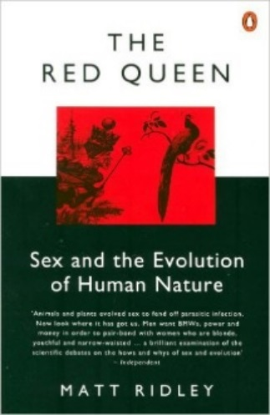
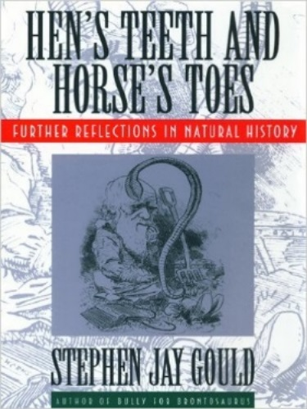
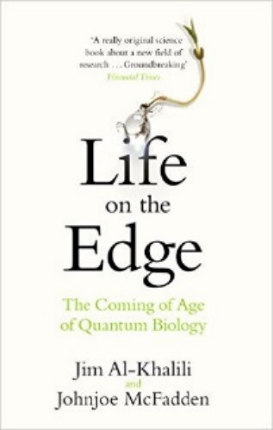
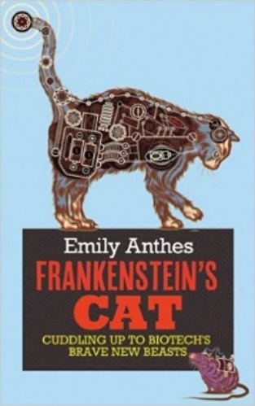
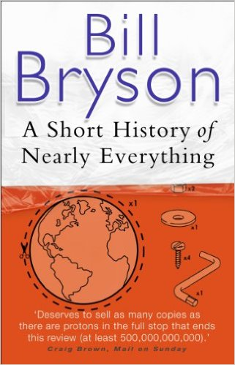
Kick back this summer with a good read. The books below are all popular science books and great for extending your understanding of Biology
Junk DNA
Our DNA is so much more complex than you probably realize, this book will really deepen your understanding of all the work you will do on Genetics. Available at amazon.co.uk
The Red Queen
Its all about sex. Or sexual selection at least. This book will really help your understanding of evolution and particularly the fascinating role of sex in evolution. Available at amazon.co.uk
Studying Geography as well?
Hen’s teeth and horses toes
Stephen Jay Gould is a great Evolution writer and this book discusses lots of fascinating stories about Geology and evolution. Available at amazon.co.uk
A Short History of Nearly Everything
A whistle-stop tour through many aspects of history from the Big Bang to now. This is a really accessible read that will re-familiarise you with common concepts and introduce you to some of the more colourful characters from the history of science! Available at amazon.co.uk
An easy read..
Frankenstein’s cat
Discover how glow in the dark fish are made and more great Biotechnology breakthroughs. Available at amazon.co.uk

Task 1: DNA & Genetic Code
In living organisms nucleic acids (DNA and RNA) have important roles and functions related to their properties. The sequence of bases in the DNA molecule determines the structure of proteins, including enzymes.
The double helix and its four bases store the information that is passed from generation to generation. The sequence of the base pairs adenine, thymine, cytosine and guanine tell ribosomes in the cytoplasm how to construct amino acids into polypeptides and produce every characteristic we see. DNA can mutate leading to diseases including cancer and sometimes anomalies in the genetic code are passed from parents to babies in disease such as cystic fibrosis or can be developed in unborn foetuses such as Downs Syndrome.

Media
Watch this:

http://ed.ted.com/lessons/the-twisting-tale-of-dna-judith-hauck
http://ed.ted.com/lessons/where-do-genes-come-from-carl-zimmer

Reading
Read this:

http://www.bbc.co.uk/education/guides/z36mmp3/revision
http://www.s-cool.co.uk/a-level/biology/dna-and-genetic-code

Revision guide pages Biology page 84 onwards & Combined Science page 68 onwards.
Activity
Produce a wall display to put up in your classroom in September. You might make a poster on publisher or do this using PowerPoint or similar. Your display should use images, keywords, and simple explanations to:

Define gene, chromosome, DNA and base pair.
Describe the structure and function of DNA and RNA.
Explain how DNA is copied in the body.
Outline some of the problems that occur with DNA replication and what the consequences of this might be.

Keep a copy of your work for your folder.

Task 2: Biological Molecules
Biological molecules are often polymers and are based on a small number of chemical elements. In living organisms’ carbohydrates, proteins, lipids, inorganic ions and water all have important roles and functions related to their properties. DNA determines the structure of proteins, including enzymes. Enzymes catalyse the reactions that determine structures and functions from cellular to whole-organism level. Enzymes are proteins with a mechanism of action and other properties determined by their tertiary structure. ATP provides the immediate source of energy for biological processes.

Media
Watch this:
https://www.youtube.com/watch?v=H8WJ2KENlK0
http://ed.ted.com/lessons/activation-energy-kickstarting-chemical-reactions-vance-kite

Reading
Read this:
http://www.s-cool.co.uk/a-level/biology/biological-molecules-and-enzymes
http://www.bbc.co.uk/education/guides/zb739j6/revision

Revision guide pages Biology page 28 onwards & Combined Science page 25 onwards.
Activity
Krabbe disease occurs when a person doesn’t have a certain enzyme in their body. The disease effects the nervous system. Write a letter to a GP or a sufferer to explain what an enzyme is.

Your letter should:
Describe the structure of an enzyme.
Explain what enzymes do inside the body.
Discuss the factors which affect enzymes.

Keep a copy of your work for your folder.

Task 3: Exchange & Transport
Organisms need to exchange substances selectively with their environment and this takes place at exchange surfaces. Factors such as size or metabolic rate affect the requirements of organisms, and this gives rise to adaptations such as specialised exchange surfaces and mass transport systems. Substances are exchanged by passive or active transport across exchange surfaces. The structure of the plasma membrane enables control of the passage of substances into and out of cells.

Media
Watch this:

http://ed.ted.com/lessons/insights-into-cell-membranes-via-dish-detergent-ethan-perlstein
http://ed.ted.com/lessons/what-do-the-lungs-do-emma-bryce

Reading
Read this:
http://www.s-cool.co.uk/a-level/biology/gas-exchange
http://www.s-cool.co.uk/a-level/biology/nutrition-and-digestion/revise-it/human-digestive-system

Revision guide pages Biology page 20 onwards & Combined Science page 17 onwards.

Activity
Create a summary sheet.
Your sheet should either: compare exchange surfaces in mammals and fish or compare exchange surfaces in the lungs and the intestines. You could use a Venn diagram to do this.

Your summary sheet should:
Describe diffusion, osmosis and active transport.
Explain why oxygen and glucose need to be absorbed and waste products removed.
Compare and contrast your chosen focus – mammals & fish or lungs & intestines.

