

BTEC Level 3 Business

Task one
- Watch the following video and make detailed notes. You will use these notes to answer the tasks in this booklet.
Costs, revenues, and profit
https://youtu.be/roWIrVObMOE
Break even
https://youtu.be/fClcp7AF_Mk?si=0xFX1kq9oIXs44Ku
Sources of finance
https://youtu.be/PEjU10ucsYs?si=5N5RrP4qtKhMul-I
Cashflow
https://youtu.be/DpUC5xRe04g?si=fDtt440_m28vAKUP
Functions of money
https://youtu.be/0jF7ksia71g?si=0sA2K3fqjoKgZz1i
Savings and investment
https://youtu.be/_VHHq9BEnV8?si=4aqQqBBwQTr310Wm
Financial institutions
https://youtu.be/3Ejk-F4t7L8?si=ky_DgA3GjbcG5qaN
Cashflow forecasting.
https://youtu.be/4SNWA_HbF6U?si=4siAJO_TPcsxPp76

Task two
Answer these questions using the notes you made from the videos.

Costs, Revenues and Profit
- What is sales revenue? How is it calculated?

- What are fixed costs? Give examples.

- What are variable costs? Give examples.

- How are total variable costs calculated?

- How are total costs calculated?

- How is profit calculated?
Break-even analysis
- What is meant by ‘break even’?

- What is the break even point?

- What is the formula for break even?

- What is the margin of safety? How is it calculated?

- On a break even chart,
- What does the vertical axis show?
- What does the horizontal axis show?
- What does the fixed cost line look like? Why?
- What does the total cost line look like?
- What does the sales revenue line look like?
- Where is the break-even point?
- Where is profit?
- Where is loss?
- How do you show actual sales?

- How do you show sales revenue and costs at actual sales?

- Where is the margin of safety?

Cash Flow
- What is cash flow?

- What are inflows?

- What are outflows?

- How is opening balance found?

- How is net cash flow calculated?

- How is closing balance calculated?

- What is the difference between cash flow and profit?

Functions of money
- What is meant by each function of money?

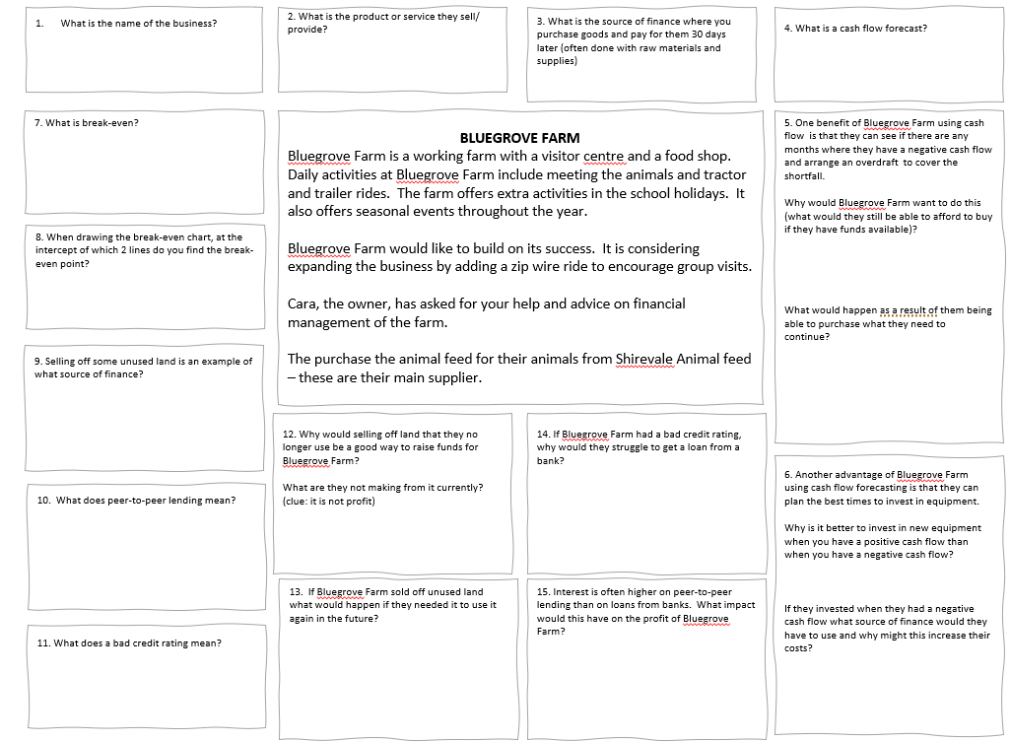

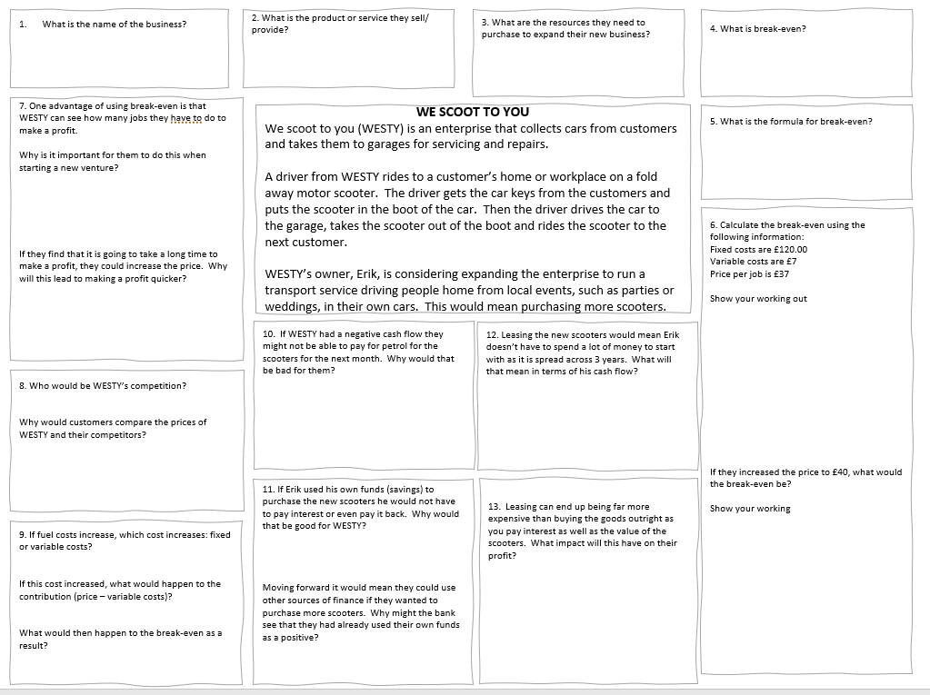

Q1 | Book-tique sells second hand books from a stall that is situated in a local market. Each book has a selling price of £1.75. Last month, Book-tique sold 428 books and the firm’s total costs amounted to £407.  Activity: Using the information above, calculate Book-tique’s profit for last month
Your workings:

Q2 | A local café bar recently bought a large quantity of hardback books from Book-tique to decorate its shelves and add atmosphere to its café. As a result, Book-tique experienced a rise in sales volume in February – see Figure 1 below. The business kept the selling price the same, at £1.75 per book, during the period shown in Figure 1.  Figure 1  Activity: Using the information in Figure 1, calculate Book-tique’s average monthly sales revenue for the first three months of the year (give your answer to two decimal places)
Your workings:

Q3 | Book-tique experienced a very difficult trading month in October, but has recently seen its monthly profits rise, due to the Christmas trading period and customers choosing to support local businesses, especially market stalls, when buying goods.  Figure 2  Activity: Using Figure 2, calculate the average monthly profit made by Book-tique between October and December (give your answer to the nearest £)
Your workings:

Q4 | Having seen its monthly profits rise at the end of last year, the owners of Book-tique were eager to see if this trend had continued into the new year. In January, they decided to increase the selling price from £1.75 to £1.80 per book. That month, the business sold 235 books, had a variable cost of £0.25 per book and fixed costs of £400.  Activity: Calculate:  a) the percentage change in selling price per book (give your answer to two decimal places)  b) the profit or loss Book-tique made in January (give your answer to two decimal places)
Your workings:

Q1 | Shampooch is a dog grooming business focused on providing a high quality and professional service. The selling price for a full groom, wash, cut and blow dry is £28 per dog with a variable cost of £8 per dog. The fixed costs are £1,000 per month.  Activity: Calculate:  a) the total variable cost if 120 dogs are groomed per month  b) the total fixed costs if 120 dogs are groomed per month  c) the total costs if 120 dogs are groomed per month
Your workings:

Q2 | Shampooch has built up an excellent reputation in its local area. During busy periods, customers have to book appointments at least two weeks in advance. As a result, the owners are considering increasing the selling price from £28 to £30 for a full groom, wash, cut and blow dry.  Activity: Assuming 110 dogs are groomed per month, calculate:  a) the monthly sales revenue if the selling price remains at £28 per dog  b) the monthly sales revenue if the selling price is increased to £30 per dog  c) the change in monthly sales revenue if the business increases its prices from £28 to £30 per dog
Your workings:

Q3 | Rebecca’s PLAICE is a high quality, traditional fish and chip shop which, despite heavy competition from several takeaways in the local area, has remained ever popular with customers who value a good, old fashioned “chippy”. The following cost and sales data has been provided by the business.  Activity: Using the information above, calculate:  a) the yearly total costs for the business  b) the yearly profit for Rebecca’s PLAICE
  Number of portions sold per year | 26,000
  Fixed costs per year | £38,000
  Variable cost per portion | £2.00
  Average selling price | £5.00
Your workings:

Q4 | Rebecca’s PLAICE has recently experienced a rise in costs from its suppliers, which has meant that the variable cost per portion has increased by 50%. The business is now thinking of increasing its average selling price by 10%, to help cover this increase in costs.  Activity: Using the relevant information in Q3 and assuming the business still sells 26,000 portions per year, calculate:  a) Rebecca’s PLAICE new level of profit taking into account both the cost and price increases  b) the change in profit levels the business will experience if these changes all go ahead
Your workings:

Q1 | A Breath of Fresh Hair is a very popular and well-established salon in Shropshire. The business has many regular customers who book their appointments months in advance. The predicted cash flows for July are shown in the graph below.  Activity: Calculate the net cash-flow for the month of July
Your workings:

Q2 | Purr-fection is a successful pet food stall which prides itself in supplying quality products. Kat, the owner, realises the importance of diet and nutrition for pets and as a result, has an excellent reputation and many loyal customers. In April, Purr-fection predicts an opening balance of £15,960 and a net cash-flow of £5,570.  Activity: Calculate the closing balance for April
Your workings:

Q3 | Georgia O’Marney always wanted to run her own clothes shop. In order to test the market, she has set up Look @ Me - a pop up boutique – to see whether there is demand in the local area. The table below shows the cash-flow forecast for her first two months of trading.  Activity: Complete the table with the missing figures
   | November (£) | December (£)
  Receipts | 1,800 | (iii)
  Raw materials | 450 | 500
  Fixed costs | 400 | 420
  Total payments | 850 | 920
  Net cash-flow | (i) | 1,080
  Opening balance | 5,240 | 6,190
  Closing balance | (ii) | (iv)
Your workings:

Q4 | Florist Nightingale is a busy flower shop based in Lincolnshire. The owners, Rose and Petal, are concerned about the seasonal nature of their business and the impact this has upon their cash-flow. They have drawn up a cash-flow forecast to illustrate the problem.  Activity: Complete the table with the missing figures
   | January (£) | February (£)
  Receipts | 750 | 10,680
  Raw materials | 250 | 3,560
  Fixed costs | 4,000 | 4,000
  Total payments | 4,250 | 7,560
  Net cash-flow | (i) | (iii)
  Opening balance | 1,000 | (iv)
  Closing balance | (ii) | 620
Your workings:

Q1 | Honest-TEA is a tea shop in a busy market town. After many years of successful trading, the owners are concerned about the arrival of a new competitor in the town. The result has been a reduction in customers. In June, the owners predict the following figures relating to the shop’s cash flow.  Activity: Calculate the total cash outflows for the month of June
Your workings:

Q2 | Fill Your Basket is a convenience store located on a busy high street in Cardiff. Despite recent growth in the convenience-store market, sales have declined due to a national chain opening a small store in the area. In March, Fill Your Basket predicts cash inflows of £18,000, cash outflows of £32,500 and an opening balance of £13,700.  Activity: Calculate:  a) the net cash-flow for the month of March  b) the closing balance for the month of March  c) the opening balance for the month of April
Your workings:

Q3 | Vans, Pans and Motorhomes specialises in everything a person could possibly need for camping, caravanning and outdoor leisure. The firm has tried various ideas to help reduce the impact of seasonality on the business and, in order to monitor this, the owners have produced a cash-flow forecast.  Activity: Complete the table with the missing figures
   | August (£ 000) | September (£ 000)
  Receipts | 3,590 | 2,190
  Raw materials | 1,070 | 1,050
  Fixed costs | 1,900 | 1,700
  Total payments | (i) | 2,750
  Net cash-flow | 620 | (iv)
  Opening balance | (ii) | 4,090
  Closing balance | (iii) | (v)
Your workings:

Q4 | Now In A Minute! is a large regional taxi firm. The firm offers traditional private hire cars, but also has contracts with several large businesses that provide Now in A Minute! with regular income. Unfortunately, in April, the business lost three of these important customers - the impact of this is shown in the cash-flow forecast below.  Activity: Complete the table with the missing figures
   | May (£) | June (£)
  Receipts | 63,000 | 46,000
  Raw materials | 22,450 | 17,450
  Fixed costs | 40,550 | 36,750
  Total payments | (i) | (iii)
  Net cash-flow | (ii) | (iv)
  Opening balance | 86,250 | (v)
  Closing balance | 86,250 | (vi)
Your workings:

