Criminology
Bridging Course –
WJEC ENTRY LEVEL FRAMEWORK SPECIFICATION
Criminology
This course Is an ideal introduction to one of the key areas of social sciences as it offers you an understanding of how criminal law is applied and its connection to social order and disorder. On a weekly basis you will be introduced to a range of case studies encouraging you to think critically about the relationship between the person, state, power and crime.

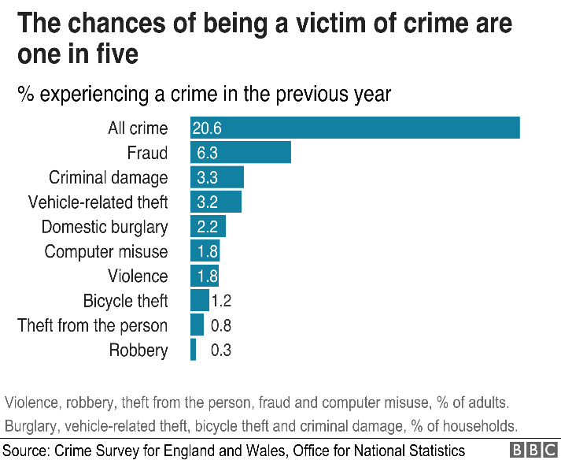
One of the aspects of criminology that this course focuses on is the importance of learning to question ideas about crime. In particular, you will become more inquisitive in your thinking about crime, law, the criminal system as well as the dangers people in society face.

This bridging course is designed to help you gain an insight in to the course, helping you get an idea of the topics that we will be covering and the themes. This will enable you to explain and question your own principles based around up bringing and your current views on crime.

Task 1:
Crimes can be categorised in a range of ways. Over time crime has evidently changed as we have had technological advancements that have led to crimes evolving and becoming more difficult to categorise. An example of this is the growth in fraud due to the rise in the use of the internet.

What we will be looking at are the different types of crime and what do they look like. How they are categorised and how a court will provide a sentence for them.

You will be expected to research all the documentation that will be provided and also watch the clips to support your learning.

White collar crime is on the rise nationally and also internationally.

I want you to research the different types of ‘white collar crime’. In particular
- Organised
- Corporate
- Professional

What is white collar crime - https://www.youtube.com/watch?v=RrxfpNip5B4

Reading –
What is white collar crime - https://www.allaboutlaw.co.uk/stage/areas-of-law/white-collar-crime

Different types of white collar crime - https://www.inbrief.co.uk/offences/white-collar-crime/

Case Study – http://news.bbc.co.uk/1/hi/business/8124838.stm

Case Study 2 - https://www.theguardian.com/society/2004/jan/14/NHS.guardianobituaries

Case Study 3 - https://www.theguardian.com/world/2019/oct/30/italy-mafia-networks-are-more-complex-and-powerful-says-minister

Key Questions

- Write 5 crimes you have heard about recently
- For each crime who are the victims of this type of crime and who are the perpetrators?
- Why do these crimes receive a lot of publicity?

Task 2 –

This task will require you to complete a report based on different types of ‘White Collar Crime’. Your report will include –

Different types of crime
Victims and the offenders
Levels of public awareness

Remember use case studies to support your views.

Do not copy and paste read and use the correct information. Also read the reading material and reference correctly if you use quotes.

Criminology films and reading list

Film/Documentaries | Link to spec
Dahmer | Unit 2
Extremely Wicked, Shockingly Evil and Vile | Unit 2
The Krays | Unit 1
Madoff | Unit 1
Book | Link to spec
WJEC Level 3 Criminology | Unit 1 – 4
The Mind of a Murderer | Unit 2
Talking with Psychopaths | Unit 2
The Secret Barrister | Unit 3

MATHS TASK
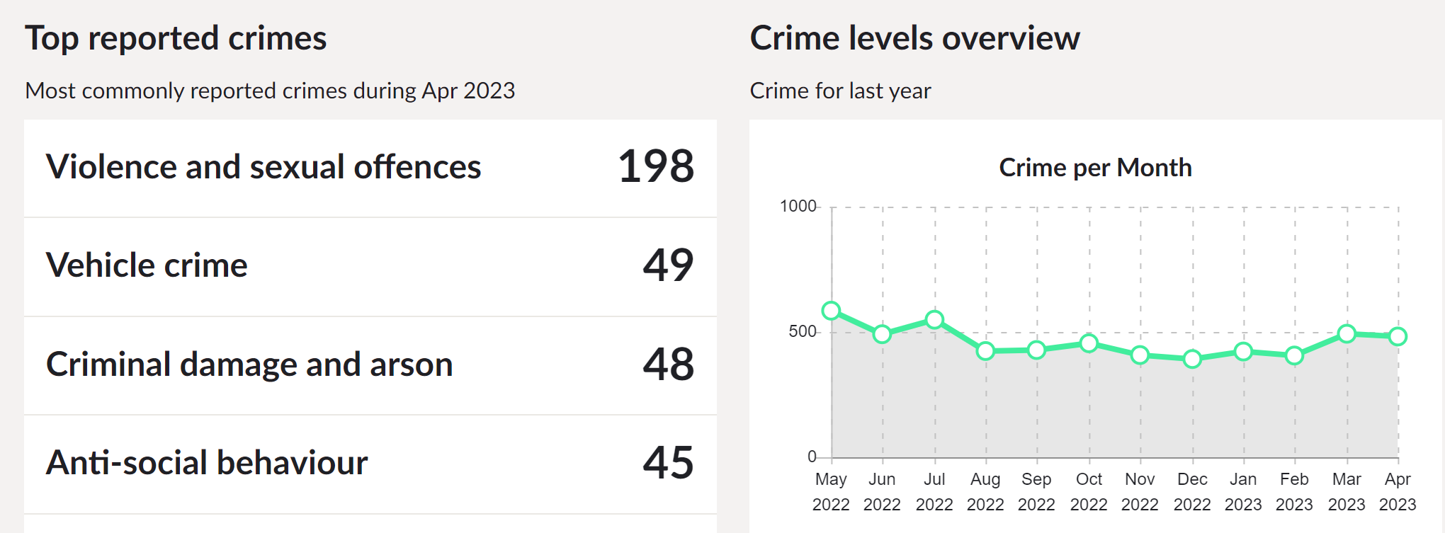
Write 5 facts from the data that you have been provided about the crimes in the DY4 area.

Task 3 -
Key Word Task -
Complete the key words -
Key word | Definition
Crime
Defendant
Prosecution
Remand in Custody
Miscarriage of Justice
Campaigns for Change
Actus Reus
Mens Rea
Acquittal

Task 4 –
Reading task
https://revisesociology.com/tag/criminology/
What have you learnt from this website?
List 5 things you can take away from the site for your learning.

Task 5 –
As part of the course, we have to look at the process of what happens from the crime scene up until the defendant is charged in court.
Watch the documentary on Netflix of Amanda Knox. Then watch the BBC documentary on Youtube: https://www.youtube.com/watch?v=erla7Ley4Tw
Record your views on the case following each documentary. What differences do you notice?

Task 6 –
As part of your course you will have to look at campaigns that have caused a change in the law. You will also have to plan your own campaign. Conduct research on one of the following campaigns. Find out what the original crime was that sparked the campaign; what the aim of the campaign was; what methods were used (eg. TV interviews, advertising, wristbands, petitions, T-shirts etc) and whether the campaign was successful.
Sarah’s Law
The Double Jeopardy Law
Slow Down for Bobby
Anti-Foxhunting Campaign

Task 7 –
Think of 3 different ways society has changed over the last 100 years. Try to be specific about the change eg. homosexuality is no longer illegal.
1. ……………………………………………………………………………………………..
2. ……………………………………………………………………………………………..
3. ……………………………………………………………………………………………..

