

Bridging Work
BTEC L3 Health and Social Care
Unit 1: Human lifespan (Examination Unit)
B1 The nature/nurture debate
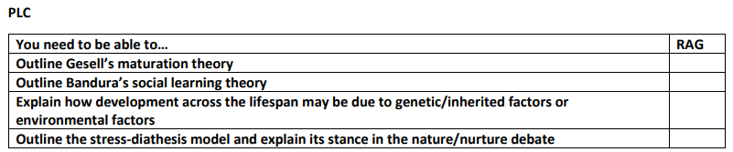
Task 1: Pre reading

Gesell’s maturation theory Bandura’s social learning theory Stress-diathesis model



Nature v Nurture debate


Task 2: Application
- Describe what is meant by the nature/nurture debate.

- Nature or Nurture?
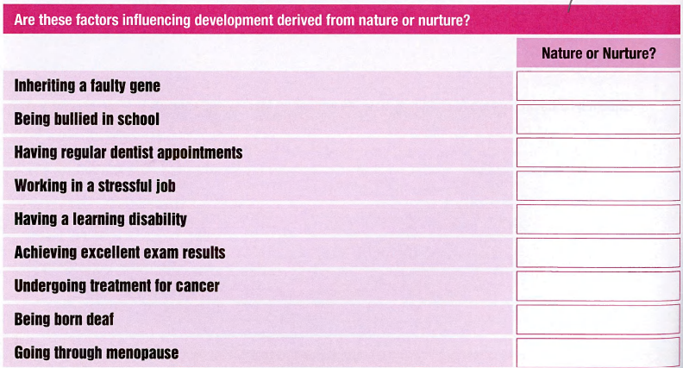
Think Harder: Pick one Nature and one Nurture factor that influences the development and give your reasons why you believe this to be the case?

- What is the main concept of Gesell’s maturation theory?

- Are these statements about Gesell’s maturation theory true or false?
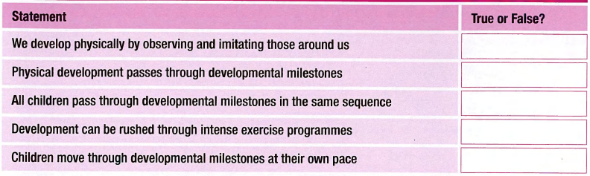
Think Harder: Pick one true and one false statement and give your reasons why you believe this to be the case?

- Natasha is 32 years old and has a 4-month-old daughter named Kelly. At a health visitor appointment, Natasha expresses concern that Kelly hasn’t rolled over yet when other babies at the ‘Mummy and Me’ group have.
Explain why Natasha should not be concerned about Kelly’s development (using what you know of Gesell’s maturation theory)

Think Harder: Give two criticisms of Gesell’s maturation theory.

- Outline two key features of Bandura’s social learning theory.

- Ally is 3 years old and her brother, Ryan, is 5 years old. Ally and Ryan are playing with their toys when they are told it is time for lunch. Ryan picks up his toys and puts them in the toybox; his mum tells him he is ‘such a good boy’ and gives him a hug. Ally sees this and then begins to pick up her own toys.
Explain why Ally began to pick up her toys (using what you know of Bandura’s social learning theory).

- Describe two ways that our physical development could be impacted by observing and imitating our role models.

- Dean 56 years old. He has been a long-distance lorry driver for 20 years and takes medication for high blood pressure. Dean is concerned that he has been having chest pains; his father had angina and Dean knows that this is one of the symptoms. Dean’s wife Mary is also concerned for his health as he often eats takeaway food and does little exercise.
Identify nature and nurture factors which may impact Dean’s development.
Nature Factors | Nurture Factors

- Define what is meant by the term ‘genetic predisposition’.

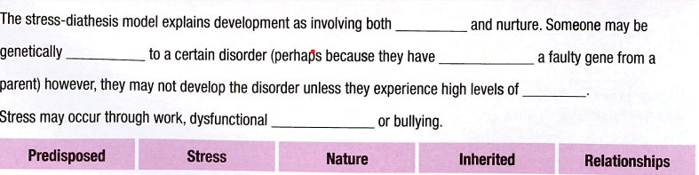
- Use the word box to help you finish this description of the stress-diathesis model.

- Janice is 48 years old. Her mother has recently been diagnosed with Type 2 diabetes and Janice is worried that she may also be at risk. Janice is a healthy weight and takes regular exercise.
Explain why Janice may or may not be at risk of developing Type 2 diabetes (using what you know of the stressdiathesis model).

Think Harder: Explain the stress-diathesis’s stance on the nature/nurture debate.
- Read the statements below and identify if they link to Gesell’s maturation theory, Bandura’s social learning theory or the stress-diathesis model.
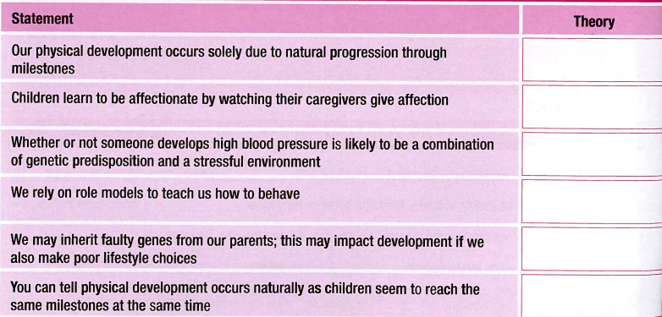

Task 3: Exam style question
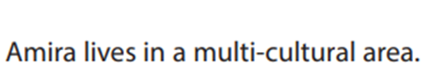
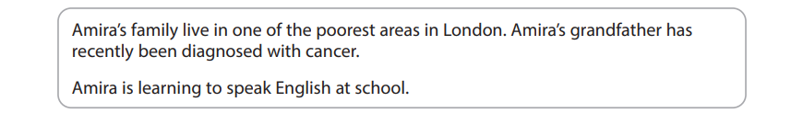

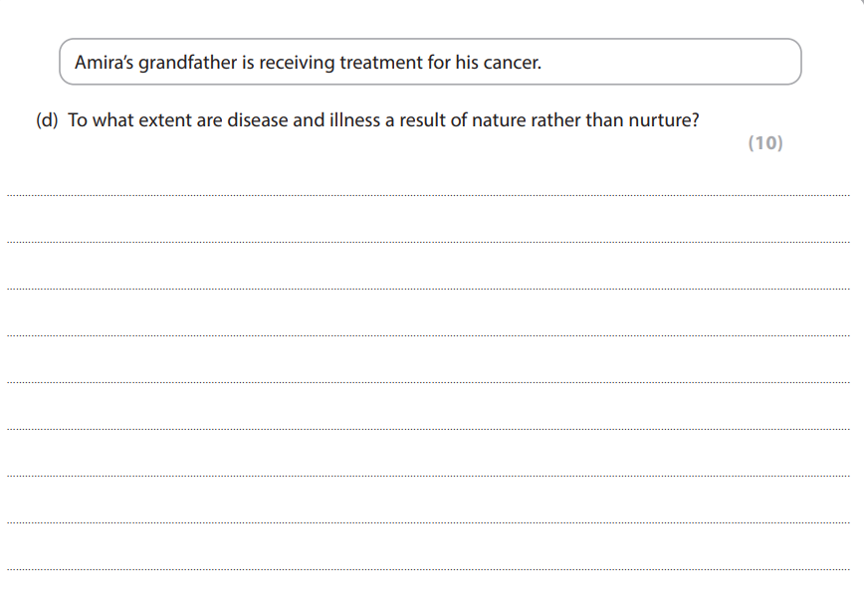

Support for task 3


