
A Level Physics
Bridging Course
Welcome to A Level Physics!

The course you are about to embark on will allow you to develop a vast array of skills while developing an understanding of some of the theories that have formed the basis of everything we understand about the modern universe.
You will need to work through the tasks in this booklet in detail and keep the work you create in a subject specific folder. The work you will complete will be in preparation for topics taught within the A Level, and you will be building on this throughout the course.

At the end of this booklet you will find also find a suggested reading list; it is very important that you engage in wider reading to add depth to your knowledge of Physics and secure the top grades. You don’t just have to read what is on this list – try and read a wide range of materials on the subject.

Have fun

Task 1:
To get the best grades in A Level Physics you will have to get good at completing independent research and making your own notes on difficult topics. Below are links to 5 websites that cover some interesting Physics topics.
Using the Cornell notes system: http://coe.jmu.edu/learningtoolbox/cornellnotes.html make 1 page of notes from each site covering a topic of your choice.
- http://home.cern/about
CERN encompasses the Large Hadron Collider (LHC) and is the largest collaborative science experiment ever undertaken. Find out about it here and make a page of suitable notes on the accelerator.
- http://joshworth.com/dev/pixelspace/pixelspace_solarsystem.html
The solar system is massive and its scale is hard to comprehend. Have a look at this award winning website and make a page of suitable notes.
- https://phet.colorado.edu/en/simulations/category/html
PhET create online Physics simulations when you can complete some simple experiments online. Open up the resistance of a wire html5 simulation. Conduct a simple experiment and make a one page summary of the experiment and your findings.
- http://climate.nasa.gov/
NASA’s Jet Propulsion Laboratory has lots of information on Climate Change and Engineering Solutions to combat it. Have a look and make notes on an article of your choice.
- http://www.livescience.com/46558-laws-of-motion.html
Newton’s Laws of Motion are fundamental laws for the motion of all the object we can see around us. Use this website and the suggested further reading links on the webpage to make your own 1 page of notes on the topics.

Task 2:
You will study nuclear decay in more detail at A level covering the topics of radioactivity and particle physics. In order to explain what happens you need to have a good understanding of the model of the atom. You need to know what the atom is made up of, relative charges and masses and how sub atomic particles are arranged.

The following video explains how the current model was discovered www.youtube.com/watch?v=wzALbzTdnc8

Describe the model used for the structure of an atom including details of the individual particles that make up an atom and the relative charges and masses of these particles. You may wish to include a diagram and explain how this model was discovered by Rutherford

Maths Subject Specific Tasks
Symbols and Prefixes
Prefix | Symbol | Power of ten
Nano | n | x 10⁻⁹
Micro | μ | x 10⁻⁶
Milli | m | x 10⁻³
Centi | c | x 10⁻²
Kilo | k | x 10³
Mega | M | x 10⁶
Giga | G | x 10⁹

At A level, unlike GCSE, you need to remember all symbols, units and prefixes. Below is a list of quantities you may have already come across and will be using during your A level course
Quantity | Symbol | Unit
Velocity | v | ms⁻¹
Acceleration | a | ms⁻²
Time | t | S
Force | F | N
Resistance | R | Ω
Potential difference | V | V
Current | I | A
Energy | E or W | J
Pressure | P | Pa
Momentum | p | kgms⁻¹
Power | P | W
Density | ρ | kgm⁻³
Charge | Q | C

Solve the following:
- How many metres in 2.4 km?

- How many joules in 8.1 MJ?

- Convert 326 GW into W.

- Convert 54 600 mm into m.

- How many grams in 240 kg?

- Convert 0.18 nm into m.

- Convert 632 nm into m. Express in standard form.

- Convert 1002 mV into V. Express in standard form.

- How many eV in 0.511 MeV? Express in standard form.

- How many m in 11 km? Express in standard form.

Standard Form
At A level quantity will be written in standard form, and it is expected that your answers will be too.
This means answers should be written as ….x 10^{y}. E.g. for an answer of 1200kg we would write 1.2 x 10³kg. For more information visit: www.bbc.co.uk/education/guides/zc2hsbk/revision

- Write 2530 in standard form.

- Write 280 in standard form.

- Write 0.77 in standard form.

- Write 0.0091 in standard form.

- Write 1 872 000 in standard form.

- Write 12.2 in standard form.

- Write 2.4 x 10 ² as a normal number.

- Write 3.505 x 10 ¹ as a normal number.

- Write 8.31 x 10 ⁶ as a normal number.

- Write 6.002 x 10 ² as a normal number.

- Write 1.5 x 10⁻⁴ as a normal number.

- Write 4.3 x 10³ as a normal number.

Rearranging formulae
This is something you will have done at GCSE and it is crucial you master it for success at A level. For a recap of GCSE watch the following links:
www.khanacademy.org/math/algebra/one-variable-linear-equations/old-school-equations/v/solving-for-a-variable
www.youtube.com/watch?v=_WWgc3ABSj4

Rearrange the following:

- E=m x g x h to find h

- Q= I x t to find I

- E = ½ m v² to find m

- E = ½ m v² to find v

- v = u + at to find u

- v = u + at to find a

- v² = u² +2as to find s

- v² = u² +2as to find u

Significant figures

At A level you will be expected to use an appropriate number of significant figures in your answers. The number of significant figures you should use is the same as the number of significant figures in the data you are given. You can never be more precise than the data you are given so if that is given to 3 significant your answer should be too. E.g. Distance = 8.24m, time = 1.23s therefore speed = 6.75m/s

The website below summarises the rules and how to round correctly.
http://www.purplemath.com/modules/rounding2.htm

Give the following to 3 significant figures:
- 3.4527
- 40.691
- 0.838991
- 1.0247
- 59.972

Calculate the following to a suitable number of significant figures:

- 63.2/78.1
- 39+78+120
- (3.4+3.7+3.2)/3
- 0.0256 x 0.129
- 592.3/0.1772

Suggested Reading List for A Level Physics:
Below is a selection of books that should appeal to a physicist – someone with an enquiring mind who wants to understand the universe around us. None of the selections are textbooks full of equation work (there will be plenty of time for that!) instead each provides insight to either an application of physics or a new area of study that you will be meeting at A Level for the first time.
- Surely You're Joking Mr Feynman: Adventures of a Curious Character
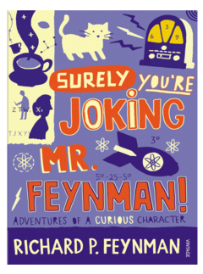
ISBN - 009917331X - Richard Feynman was a Nobel Prize winning Physicist. In my opinion he epitomises what a Physicist is. By reading this books you will get insight into his life’s work including the creation of the first atomic bomb and his bongo playing adventures and his work in the field of particle physics.
(Also available on Audio book). https://www.waterstones.com/books/search/term/surely+youre+joking+mr+feynman++adventures+of+a+curious+character

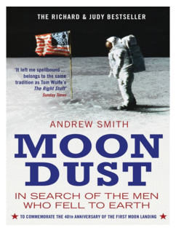
Moondust: In Search of the Men Who Fell to Earth

ISBN – 1408802384 - One of the greatest scientific achievements of all time was putting mankind on the surface of the moon. Only 12 men made the trip to the surface, at the time of writing the book only 9 are still with us. The book does an excellent job of using the personal accounts of the 9 remaining astronauts and many others involved in the space program at looking at the whole space-race era, with hopefully a new era of space flight about to begin as we push on to put mankind on Mars in the next couple of decades.

https://www.waterstones.com/books/search/term/moondust++in+search+of+the+men+who+fell+to+earth

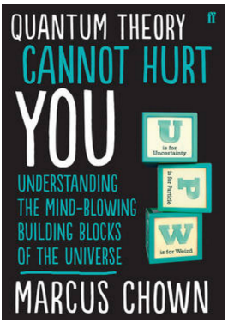
Quantum Theory Cannot Hurt You: Understanding the Mind-Blowing Building Blocks of the Universe

ISBN - 057131502X - Any Physics book by Marcus Chown is an excellent insight into some of the more exotic areas of Physics that require no prior knowledge. In your first year of A-Level study you will meet the quantum world for the first time. This book will fill you with interesting facts and handy analogies to whip out to impress your peers!

https://www.waterstones.com/book/quantum-theory-cannot-hurt-you/marcus-chown/9780571315024

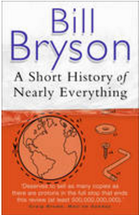
A Short History of Nearly Everything

ISBN – 0552997048 - A modern classic. Popular science writing at its best. A Short History of Nearly Everything Bill Bryson’s quest to find out everything that has happened from the Big Bang to the rise of civilization - how we got from there, being nothing at all, to here, being us. Hopefully by reading it you will gain an awe-inspiring feeling of how everything in the universe is connected by some fundamental laws.

https://www.waterstones.com/books/search/term/a+short+history+of+nearly+everything

Thing Explainer: Complicated Stuff in Simple Words

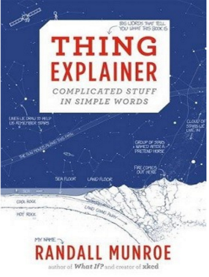
ISBN – 1408802384 - This final recommendation is a bit of a wild-card – a book of illustrated cartoon diagrams that should appeal to the scientific side of everyone. Written by the creator of online comic XTCD (a great source of science humour) is a book of blueprints from everyday objects such as a biro to the Saturn V rocket and an atom bomb, each one meticulously explained BUT only with the most common 1000 words in the English Language. This would be an excellent coffee table book in the home of every scientist.

https://www.waterstones.com/book/thing-explainer/randall-munroe/9781473620919

