Introduction to A level psychology
Topics | Task | Evidence
- Approaches | Answer the questions on worksheet 1 using the following resources  Wundt’s Contribution to Psychology | Reference Library | Psychology | tutor2u  Classical Conditioning | Reference Library | Psychology | tutor2u  Operant Conditioning | Reference Library | Psychology | tutor2u  Cognitive Approach | Topics | Psychology | tutor2u  Biological approach | Topics | Psychology | tutor2u  Social Learning Theory (Bandura) | Reference Library | Health & Social Care | tutor2u | Complete worksheet 1
- Biopsychology | Glossary grid | Complete worksheet 2
- Psychopathology | Fact file | Complete worksheet 3
- Research methods | Glossary grid  Aims and Hypotheses | Reference Library | Psychology | tutor2u  Independent and Dependent Variables | Reference Library | Psychology | tutor2u  Control of Extraneous Variables | Reference Library | Psychology | tutor2u  Types of Experiment: Overview | Reference Library | Psychology | tutor2u  Experimental Design | Reference Library | Psychology | tutor2u | Complete worksheet 4
- Social influence | Research task | Complete worksheet 5

Worksheet 1: approaches
- Who is Wundt?

- Write down two facts about Wundt.

- Explain what Pavlov found in 30 words.

- Explain what Skinner found in 30 words.

- Who was Bandura and why was his research so important? What did he say about how we learn behaviour?

- What does the biological approach assume about behaviour?

- What does the cognitive approach assume about behaviour?

Worksheet 2: biopsychology
Key words | Definition
The central nervous system
The peripheral nervous system
Somatic nervous system
Autonomic nervous system
Endocrine system
Gland
Fight or flight
Neuron
Synaptic transmission
Neurotransmitter
Excitation
Inhibition
Action potential

Worksheet 3: psychopathology
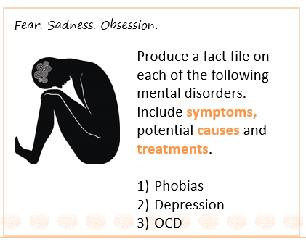
Mental disorder | Symptoms | Causes | Treatment
- Phobias
- Depression
- OCD

Worksheet 4: Research methods
Key word | Definition
Aim
Hypothesis
Independent variable
Dependent variable
Extraneous variable
Confounding variable
Lab experiment
Field experiment
Quasi experiment
Natural experiment
Independent groups design
Repeated measures design
Matched pairs design

Worksheet 5: social influence
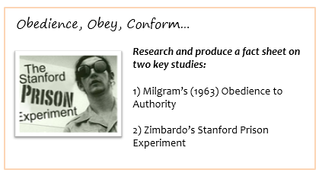

Researcher | Why is he important? (Explain his research, his findings and his conclusions)
- Milgram
- Zimbardo

