GCSE – English Literature
Paper 1- Macbeth
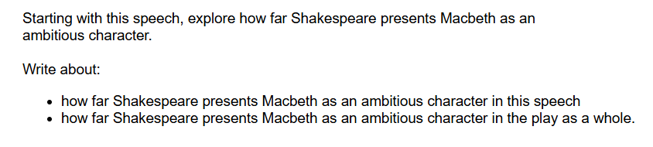Grade 3
In the play, Macbeth, Shakespeare presents Macbeth as an ambitious character by making him power–hungry throughout. This is presented in the quote ‘I have no spur to prick the sides of my intent, but only vaulting ambition which o’erleaps itself…’ from the text. This quote shows that Macbeth was given a little bit of power, then wanted the whole world. The word phrase ‘vaulting ambition’ shows that he is eager to gain the same power as Duncan and will do whatever it takes to get it. Shakespeares intention by this could be that he wanted to show macbeth as a character that was not willing to give up untill he became king.
Another way Macbeth was presented as ambitious was by the quote ‘stars hide my fires, let not light see my black and deep desires’. This shows that he was willing to murder and continue to do so, as the power and title he has been given hides his sins and stops people from believing he did it. The phrase ‘black and dark desires’ shows that Macbeth was not finished with murdering innocent people and was going to continue gaining power from it. The readers reaction could be wanting other characters, like MacDuff, to figure out what Macbeth is doing and for him to be stopped.
Another way Macbeth is presented as ambitious is by the quote ‘false face must hide what false heart doth know’. In this quote Macbeth is saying to lady Macbeth that she needs to hide her true expressions if she wants to keep the power they worked so hard to get. In the quote, the part that states ‘false heart doth know’ shows that he is not as weak as he is made out to be by Lady Macbeth and will to everything in his power to keep it hidden.

10/30 = 33%

Grade 4
In his tragic play, Shakespeare presents Macbeth as an ambitious character throughout the play. At the start of the play, Macbeth is seen as a brave warrior, who shows his loyalty to King Duncan through battle and gets rewarded with the title ‘Thane of Cawdor’. However, as the play progresses, Macbeth’s ambition is inflamed by Lady Macbeth and the three witches, as he aspires to be King of Scotland, which leads him to commit the Heinous act of regicide and hiring murderers to kill his friend, Banquo. At the end of the play, Macbeth turned from a righteous brave warrior to a tyrannical character, as his ambition has affected him and guilt starts to wash over him. Shakespeare does this to highlight that when power enters the wrong hands, there are consequences that can affect that person and the people around them.
In this extract, Shakespeare presents Macbeth as an ambitious character through his unloyalty as he forms a plan to kill King Duncan and take the title King of Scotland. This is demonstrated on the line: “He’s here in double trust.” This suggest that no one would suspect Macbeth as King Duncan’s murderer as he has shown his loyalty towards him. Furthermore, the word ‘trust’ implies that not only does King Duncan see him as loyal but that he confides in Macbeth and trusts Macbeth with his life. Additionally, the word ‘double’ could have a connotation of the two sides to Macbeth. To King Duncan and others, Macbeth wants to protect King Duncan with his life, but deep inside Macbeth is forming a devious plan, waiting to execute it.
As the play progress, Shakespeare also exposes that Lady Macbeth manipulates Macbeth, increasing his ambition to commit the heinous act of regicide. This is illustrated in the line: “When you’d durst do it, then you are a man.” Here, Lady Macbeth questions Macbeth’s masculinity, manipulating him to think killing King Duncan is the only way to prove he is a man. The word ‘durst’ implies Lady Macbeth is trying to secretly command Macbeth by hurting his ego and masculinity, as she sees him as weak. This increases his ambition as he would want to prove he’s a strong and masculine man, who is not afraid of killing anyone, including his own king.
At the end of the play, Macbeth’s ambition turns into guilt as he becomes a tyrant to Scotland, murdering everyone who is seen as a threat to his reign on the throne. This is illustrated in one line: “Not a King, but a tyrant.” Here, Macduff believes that Macbeth does not deserve the title of King as all he has done was brought chaos upon Scotland and has not proven himself worthy of being King. The adjective ‘tyrant’ suggests Macbeth’s unfit ruling and the chaos he has brought to the throne. Furthermore, Macduff brings an end to Macbeth’s reign and the Great Chain of Being is restored to the throne and peace is brought back to Scotland. Perhaps, Shakespeare does this to expose that if you break the Great Chain of Being, you bring chaos towards yourself.
14/30 = 47%
An Inspector Calls – paper 2
Grade 3
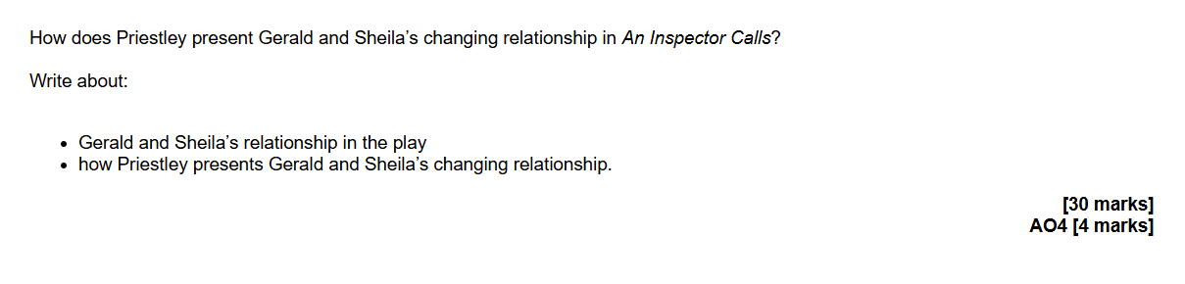In J.B Priestley’s an inspector calls, Priestley presents the changes of the characters Gerald and sheila’s relationship throughout the play. In the first scene when the Birling family and Gerald croft are enjoying Sheila and Geralds engagement party, this is when Gerald is described as ‘a wonderful fairy prince’ which presents him as a very good man and to be the best of the best.
However, interrupting the party comes in the inspector, and he confesses what had been happening during last summer and shelia states ‘you wouldn’t even come near me last summer’, this is the first breaking point for the couple as Shelia learns that it was because of Eva smith and returns her engagement ring back to Gerald.
This can be seen as a big change in the play for Gerald and Shelia as the audience notices + Shelia beginning to be come more mature and independant.
In Priestley’s an inspector calls, Gerald and Shelia’s relationship changes quiet quickly. We can see at the start of the play that the two were in love with one another. Until Shelia finds out the truth about Gerald and his mistress (Eva) and gives him back her engagement ring, this can be seen as moment in the play were Shelia begins to change an become more independant and change her social views.
Near the end of the play, Gerald offers Shelia her ring back as they found out that Inspector Goole wasn’t a real inspector, but Shelia rejected his offer. Gerald stated to Shelia ‘it’s all okay now, what about this ring?’ which shows his arrogancy and selfishness.
We can see that at the end of the play Shelia begins to voice the inspector and become a vehicle for him. However Gerald has still got a fixed mindset and his views have not been changed.

10/30 = 33%

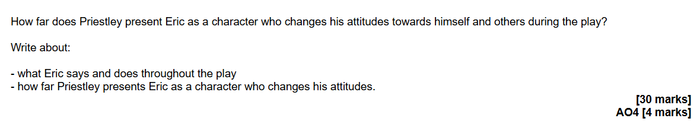Grade 4
Priestley throughout the play makes Eric conscience of his actions and the consequences of them.
At the beginning of the play Eric is presented to not be mature, to be ‘squiffy’ at his sister’s engagement. Showing that he doesn’t really care about who’s around.
However, when Inspector Goole arrives announcing about a young girl’s suicide, Eric’s behaviour changes. Eric becomes more rigid andaware. After Mr Birling tells the Inspector how he had fired the girl (Eva) because she did a protest to earn more money and he refused. Eric becomes angry saying that ‘they’re people’. Not understanding why his father wasn’t giving the women a raise ‘they need it more’ than them. This shows the audience the difference between the younger and older generation. Allowing Eric to know not to follow his dad’s behaviour. As it only leads to tragedy.
Another example when Eric learns an important lesson would be when he learns the consequences of his own actions. After Eric reveals his story with Eva, he finds out how his actions impacted on her. Eric met Eva/Daisy at the Palace Bar, aware the type of women in there (prositutes). They began talking and ended up having sexual intercourse. However, they began to have more sexual intercourse throughout the time of ‘getting to know’ each other. Due to Eric’s threats to Eva. Most of the time Eric was tipsy, unaware of his actions. Eva then discovered she was pregnant and decided to tell Eric.
Eric tried his best to support Eva and by doing so he decided to steal his father’s money from the factory. Telling Mr Birling ‘You’re not the type of fathe a chap would go to when he’s in trouble’ showing the distant relationship they both have.
By giving the stolen money Eric would feel relieved, but that was not the case as Eva didn’t accept it, knowing it was stolen making aware how society is different to how higher class people describe it. How people would rather work for their money and help others first.
The Birling family brought up their children (Eric and Sheila) to think about themselves but didn’t notice how times were/are changing. Most importantly society is changing alongside them.
Priestley makes Eric (and Sheila) know what they’re actions and take responsability which contrasts with Mr and Mrs Birling who don’t care or want to ruin their reputation because of a working class girl.
Eric takes responsability, however he knows that he wasn’t the only one in the wrong. ‘We all helped killing her’ knowing his role but also trying his best in showing the others that they also played a part. This allows the audience toe see how Eric throughout the play has developed but also got to learn how society is truely like. Learning important lessons not to make the same mistakes again. That he has a second chance to correct his wrongs, which many are unable to do.

12/30 = 40%

