GCSE – English Language
Paper 1: GCSE English Language Mark scheme Paper 1 June 2018
Question 2
How does the writer use language here to convey Mr Fisher’s views on books and stories of the past?

You could include the writer’s choice of:

- words and phrases
- language features and techniques sentence forms.

Grade 3 | Grade 4
Mr Fisher likes the books of the past because he uses the word ‘golden’. The writer says the stories ‘pounced like tigers’ so they must have made the reader jump. | The writer uses the adjective ‘golden’ to describe books of the past, which makes it sound as if Mr Fisher thinks they were bright and enjoyable. The stories ‘ran like gazelles and pounced like tigers’, so they were really fast and some parts jumped out at you.

Question 3
You now need to think about the whole of the source. This text is from the beginning of a short story.
How has the writer structured the text to create a sense of anticipation in the reader? You could write about:
- what the writer focuses your attention on at the beginning of the source
- how and why the writer changes this focus as the source develops any other structural features that interest you.

Grade 3 | Grade 4
At the beginning, the writer focuses our attention on Mr Fisher thinking about how the boys he teaches don’t like books. Then he thinks back to the past and shows us it was different. | Near the beginning, the writer focuses our attention on Mr Fisher’s thoughts, and we learn how hard it is for him to interest his students in creative writing. Then it says ‘Mr Fisher remembered a time’ and the focus switches to the past when the boys liked stories, so it shows us it was different then.

Question 4
Focus this part of your answer on the second part of the source, from line 25 to the end.

This part of the extract shows Mr Fisher’s reaction to Tibbet’s work to be extreme.

To what extent do you agree? In your response, you could:
- consider your own impressions of what Mr Fisher expected Tibbet’s homework to be like
- evaluate how the writer conveys Mr Fisher’s reaction to what he discovers support your response with references to the text.

Grade 3 | Grade 4
Mr Fisher thinks Tibbet’s homework is going to be bad, but it turns out to be good. It says ‘not a brilliant scholar by any means’ so Mr Fisher didn’t expect it to be any good. I agree Mr Fisher’s reaction is extreme. This is shown in the short sentence ‘His breathing quickened, stopped, quickened again’. | Mr Fisher expected Tibbet’s homework to be bad. He says ‘not a brilliant scholar’. He also ‘took a deep breath’, which tells us he didn’t really want to mark the book. I think Mr Fisher is surprised when he discovers Tibbet’s story is good, and I agree he has an extreme reaction. He starts to sweat and ‘his breathing quickened, stopped, quickened again’. This is a short sentence used for effect. You read it really quickly and it makes it seem like he can’t breathe properly because he’s so excited.

Question 5
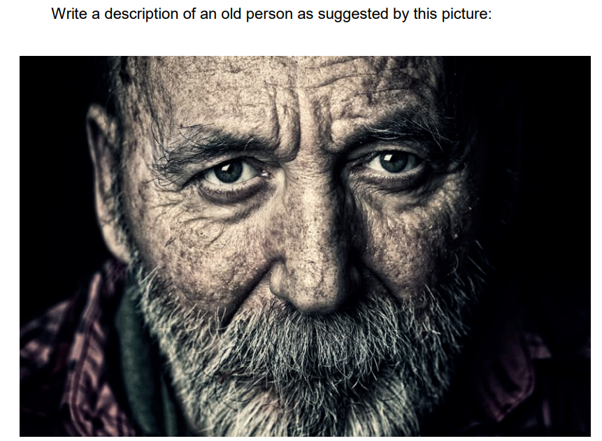
Grade 3 | Grade 4
The old man’s face is covered in deep wrinkles that show he has lived a long and difficult life. His grey beard is thick and untidy, spreading across his chin like rough wool. His eyes look tired but thoughtful, as if he has seen many things he will never forget. The skin on his face is dry and cracked, especially around his eyes and mouth, which makes him look worn down. He stares straight ahead, giving the impression that he is serious and quietly sad. | The old man’s face is a map of deep lines and creases, each wrinkle suggesting years of hardship and experience. His tangled grey beard frames his mouth, making him appear rugged and unkempt. His pale eyes seem heavy with memories, yet they still hold a faint glimmer of awareness, as though he is carefully observing the world around him. The rough texture of his skin, cracked and weathered, makes him look fragile but strong at the same time. He fixes the viewer with a steady gaze, creating a sense of quiet strength mixed with loneliness.

Paper 2: June 2024 MS - Paper 2 AQA English Language GCSE
Question 2
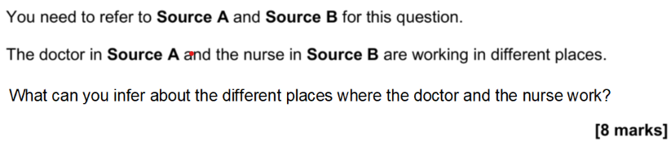
Grade 3 | Grade 4
In Source A the doctor is in a hospital because it says ‘book an MRI scan, refer to rheumatology, arrange an ECG test’, which shows there is a lot of things. This is different to Source B because she is on a wharf where there is ‘a poor artilleryman stretched upon a wooden pallet’, which shows there isn't very much there. | In Source A the doctor is part of a busy hospital. It says ‘book an MRI scan, refer to rheumatology, arrange an ECG test’, showing there are lots of options for helping people. However, the wharf in Source B is very different as there are not so many options because it says ‘a poor artilleryman stretched upon a wooden pallet’. This suggests a much more basic place without as much equipment.

Question 3
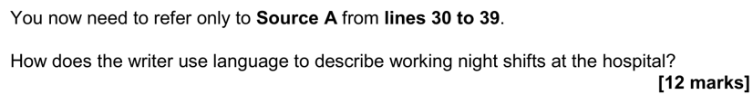
Grade 3 | Grade 4
The writer describes working night shifts when he says ‘sailing the ship alone’. This is a metaphor that he uses to compare working on the night shift in a hospital to sailing a ship by himself. | The writer uses a metaphor to compare the difficulty of working on the night shift to ‘sailing the ship alone’. The use of ‘ship’ suggests that he has a big job to do and there is nobody there to help him with it.

Question 4
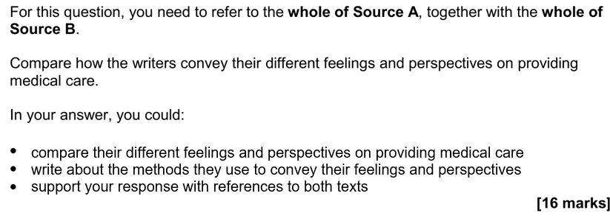
Grade 3 | Grade 4
The doctor in Source A finds working in the hospital hard. He uses repetition ‘Sure it was hard work, sure the hours were bordering on inhumane and sure I saw things that have scarred my retinas to this day, but I was a doctor now’, which shows that it wasn’t an easy job to do. However, in Source B the nurse is more positive because she says ‘the sympathy and brotherly love shown by the strong to the weak’. The word ‘sympathy’ shows that she feels sorry for them but she is still having a better time. | The doctor in Source A had a tough experience training to be a doctor. He says, ‘Sure it was hard work, sure the hours were bordering on inhumane and sure I saw things that have scarred my retinas to this day, but I was a doctor now.’ This list shows that he had some difficult experiences on his way to being a doctor. However, in Source B, the nurse is glad to have helped the wounded soldiers. She says ‘the sympathy and brotherly love shown by the strong to the weak’. She uses the word ‘brotherly’ to describe how they treat the patients as if they were as close as brothers. This shows that she was impressed by how caring they were.

Question 5
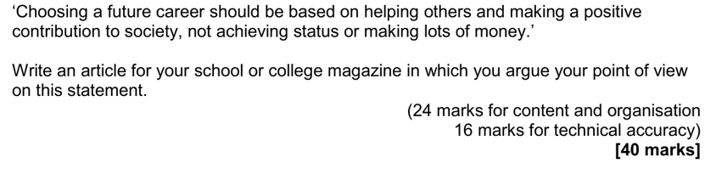
Grade 3 | Grade 4
I think pepole should pick a job that helps others because its the right thing to do. Jobs like nurses and teachers help pepole every day and make life better. If everyone only wanted money then society would be bad and unfair. Having lots of money dont always make you happy but helping someone can make you feel good inside. For example a nurse helps sick pepole and saves lifes even though they dont get payed loads. This shows helping others is more important than status. | Choosing a career should be about making a positive difference rather than just becoming rich or famous. Many of the most valuable jobs in society, such as doctors, firefighters and support workers, are not done for status but because they help others. These people often work long hours in difficult conditions, yet they continue because they care about improving lives. Although money is important for survival, it should not be the main reason for choosing a future. If young people focus only on high-paying jobs, we risk forgetting what truly matters, which is kindness, responsibility and community. Therefore, a career that helps others is more meaningful than one chosen only for money.

