Grade 3-4 Descriptors - Sociology
What is required to achieve a grade 3? | What is required to achieve a grade 4? | What is the difference in the work of a grade 3 and 4 student? | What in-class interventions could move students over the grade 4 border? Priority interventions
12-mark question  - A limited statement of sociological knowledge, often basic or generalised  - May correctly identify one sociological concept or theory, but definitions are weak, inaccurate, or implicit  - Explanations are descriptive rather than analytical  - Very limited use of:  - Sociological terminology  - Examples (may be generic or common-sense)  - No clear evaluation:  - Little or no consideration of alternative views  - No judgement or conclusion  - Answers often read like “telling me what it is”, rather than “explaining why it matters”. | - Generally accurate sociological knowledge relevant to the question  - Clear and correct definitions of key sociological terms (Tier 2 and Tier 3)  - Ability to:  - Explain at least two sociological points, perspectives, or theories  - Shows some application to the question (AO2), even if not always sustained  - Begins to demonstrate analysis (AO3):  - Uses phrases such as because, therefore, this suggests  - Makes a structured attempt at evaluation, e.g.:  - Strengths and weaknesses of a theory  - Comparison of perspectives (e.g. Functionalism vs Marxism)  - A basic conclusion is present, even if underdeveloped  - Answers move beyond description and start to explain and evaluate, even if unevenly. | Common weaknesses holding students at Grade 3.  - Vague use of sociological language (e.g. “society says…”)  - Naming a theory without explaining it  - Writing everything they know rather than answering the question  - No evaluation or judgement  - Poor extended-writing structure | Live modelling of full 12-mark answers (verbal + written)  - Sentence stems / structure strips, e.g.:  - One sociological explanation for this is…  - This suggests that…  - However, an alternative view is…  - Evaluation prompting:  - “Because…”  - “Therefore…”  - “This suggests…”  Required Structure for a Grade 4 12-Mark Answer  - Point – Clear sociological point or theory  - Evidence – Sociologist, study, or applied example  - Explain – How and why this answers the question  - Link – Back to the question and evaluate the strength/weakness or alternative view

Grade 4 Pupil Response – 8/12 | Comments
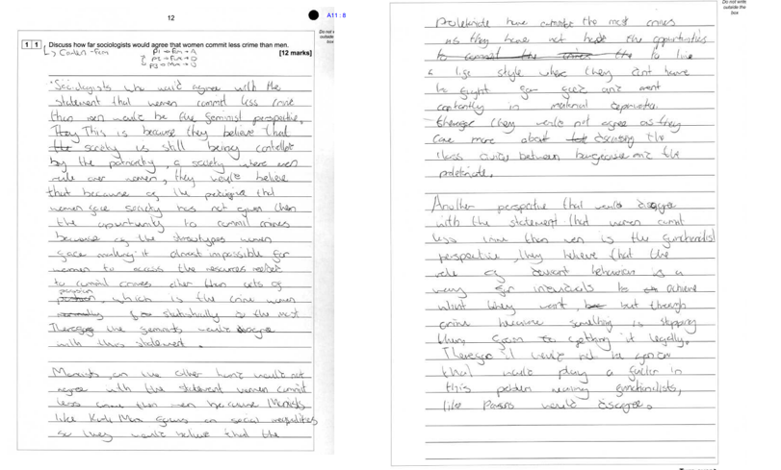 | - Pupil MF was generally accurate sociological knowledge relevant to the question and was able to explain at least two sociological points, perspectives, or theories  - Begins to demonstrate analysis (AO3):  - Uses phrases such as because, therefore, this suggests  - Makes a structured attempt at evaluation, e.g.:  - Strengths and weaknesses of a theory  - A basic conclusion is present, even if underdeveloped  - Answers move beyond description and start to explain and evaluate, even if unevenly.
Grade 3 Pupil Response 5/12 | Comments
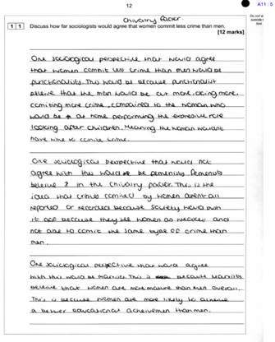 | - Pupil AM gave a very limited statement of sociological knowledge, which is substantially weaker than Pupil MF.  - The Explanations are descriptive rather than analytical  - Very limited use of:  - Sociological terminology  - Examples (may be generic or common-sense)  - No clear evaluation:  - Little or no consideration of alternative views  - No judgement or conclusion  - Answers often read like “telling me what it is”, rather than “explaining why it matters”.

