Grade 3-4 Descriptors – Religious Studies
What is required to achieve a grade 3? | What is required to achieve a grade 4? | What is the difference in the work of a grade 3 and 4 student? | What in-class interventions could move students over the grade 4 border? Priority Interventions
8 Mark Questions  - Pupils can explain one religious point of view specifically.  - Does not specifically link to religious teachings or include quotes from Holy Books.  15 Mark Questions  - A limited statement of information about the religious idea, belief, practice, teaching or concept.  - Often limited to one view effectively but limited to a broad description of another with no real specific points. (too vague)  - A limited understanding of how belief influences individuals, communities and societies  - No clear conclusion or analysis of different views. | 8 Mark Questions  - Pupils can explain one religious point of view well and able to form brief judgements of a second.  - Can make some specific links to scripture but require a more direct analysis to enhance analysis  15 Mark Questions  - A good, generally accurate answer showing knowledge and understanding of the religious idea, belief, practice, teaching or concept.  - Able to specifically look at two points to an effective level but often misquote or are vague in some areas.  - A good understanding of how belief influences individuals, communities and societies  - A limited but structured attempt at looking at the strengths and weaknesses of different views.  - Able to make specific links to their own views. | - Limited areas around knowledge. Definitions are weak. (Specifically, Tier 2 and 3 - Incarnation)  - Structure of Extended Writing. (Point, Evidence, Explain and Link to question)  - Pupils are limited in being able to infer and draw conclusions from specific religious texts and link belief to the purpose to why it is significant | - Live modelling – verbal and written  - Worked examples – highlight success criteria, highlight errors  - Sentence stems / structure strips  - Prompting for “because / therefore / this suggests”  - Strategic chunking + pause points  - Guided writing (whole-class or small group) ‘I do / we do / you do’ re-teach (90 seconds)

Grade 4 Pupil Response – 8/15 | Comments
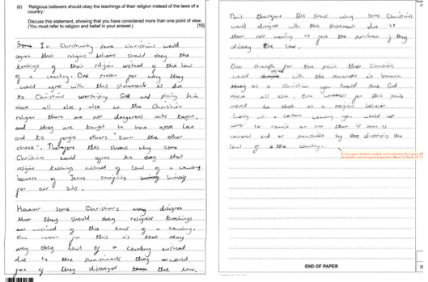 | - Pupil RE wrote a good, generally accurate answer showing knowledge and understanding of the religious idea, belief, practice, teaching or concept.  - They were able to specifically look at two points to an effective level but often misquote or are vague in some areas.  - A limited but structured attempt at looking at the strengths and weaknesses of different views.  - Able to make specific links to their own views, but were lacking an effective conclusion.
Grade 3 Pupil Response 4/15 | Comments
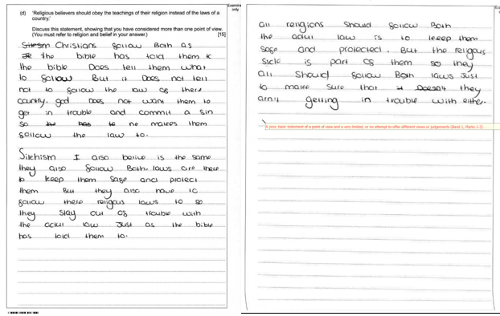 | - Pupil DR gave a limited statement of information about the religious idea, belief, practice, teaching or concept.  - They were very limited to one view effectively but limited to a vague description of Sikh views.  - A very weak structure with no attempt of looking at the strengths and weaknesses of different views.  - No clear conclusion or analysis of different views.

