Task 2 – Market research methods
To be successful, all businesses need to conduct market research. Market research is gathering information to know more about businesses and different aspects of it and to know more about their competitors when they start up the business and the needs of customers relating to price, quality etc. The reason businesses conduct research is to ensure their customers are satisfied and to also be aware of their competitors. It is important to have satisfied customers because if they are satisfied then they will become loyal customers and come back to your service or come back to purchase the product you’re selling.
Businesses can use either primary or secondary research methods. Primary research is research you do yourself whereas secondary research is research conducted by someone else.
With primary research, you can use methods such as questionnaires/survey which is where you write down questions which allows the individual/group taking your survey or questionnaire, answer those questions and those answers add onto your knowledge, giving you more information. A second method is consumer panel which is where you meet with a group of professionals in an industry who you share your ideas with, and they will give you feedback afterwards. A third method is focus groups which is where you meet with a group, potentially a target audience and they will give you feedback on your ideas. A fourth method is testing/observing where you observe an audience’s reaction on your business idea. A fifth method is visit/observations, where you go to your competitors and observe how they run their business and take ideas and possibly use those ideas for your business. Another one is interviews which is where you can meet someone face to face instead of online and ask verbal questions to an individual to get feedback about a business, an advantage of this method is verbally asking questions helps you dig deeper for a more detailed response.
With secondary research, you can use methods online such as doing online research where you just type in any question you need to, to gather knowledge and it will give you an answer. Another method is books/journals/magazines which are where you can read and get information from them.
Below are the methods of research that the business I have chosen used/uses:
The research method used by Nigel Evan’s is questionnaires which is a primary research method. The data Nigel Evan’s collected was both qualitative and quantitative data. This is when, the quantitative data is numeric data which is easy to analyse and qualitative is long response answers which are hard to analyse. Nigel Evan’s used this method to find out if customers would be interested in his goods/services. Nigel Evan’s used a questionnaire as it helps gather information which will help Nigel Evan’s know what he must do within his business to make it successful, for e.g. looking at what prices customers would like, what products customers are interested in etc. For example, Nigel Evan’s asked the following question in the questionnaire: “Would you be interested in wholefoods, liquid refills and eco goods?” By asking this question, Nigel Evan’s got the information he needs to know if it’ll help make his business successful. When Nigel Evan’s asked this question, he found out that customers are in fact interested in wholefoods, liquid refills and eco goods. This then impacted his business as he knew that if he sells those products then it will make his business successful as customers would be happy. Nigel Evan's also asked, "Have you ever bought eco goods and if so, what was the price?”, Evan’s asked this so he could figure out how to start up the business and how to introduce the products price which he has figured out successfully. One thing Nigel Evan’s has found out about the customer needs is that they like a fair price, for example up to £5-10. When Nigel Evan’s found out what the price was for the eco goods the person answering the questionnaire bought previously, he knew where about to set his price for his products (eco goods, wholefoods etc). One thing Nigel Evan’s has found out about competitor’s behaviour is Evan’s asked the following question “Have you ever purchased anything from plentiful wholefoods and if so, how much did you spend?”. From asking this question Nigel Evans has found out how much his competitors sell their products for, (prices are £5-10), which helps him understand how to introduce the prices of his products which has a positive impact on his business. It will impact his business is the prices of Nigel Evan’s product could attract customers etc. When Nigel Evan’s was doing his research, he found out that the supplier plentiful wholefoods use is the best supplier, so he now uses the same supplier for his business.
Another research method used by Nigel Evan’s is doing research online, which is a secondary method. The data Nigel Evan’s collected was qualitative. This is when, qualitative long response answers and is hard to analyse. Nigel Evans has used this method as it is free and easy to find out information to help Evan’s with his business. One thing Nigel Evan’s has found out about the customer needs is a good service. Nigel Evan’s has done this by looking at reviews left online about businesses like his, for example, plentiful wholefoods, to see what customers want/need. One thing Nigel Evan’s has found out about the competitor's behaviour is prices. Nigel Evan’s has done this by looking at how much plentiful wholefoods set their prices at for their products. By doing this Nigel Evan’s has found out where to set his prices for the products he’ll be selling (wholefoods, eco goods etc). Nigel Evan’s found out that the prices are that the business ‘plentiful wholefoods’ set their prices under £10. This helped Nigel Evans with his business as using the information of what customers want/need and looking at competitor's behaviours with the prices they set up for their products, in a successful way, lets him know how to make his business a success and running effectively, which then also helps him meet his aims. Nigel Evan’s successful business will be making a good profit, giving a good service where customers are happy, etc.
Below is the evidence for the customer’s needs (reviews about the service at plentiful wholefoods) and the competitor's behaviour (prices of products):
Evidence for the customer's needs: Evidence for the competitor's behaviour: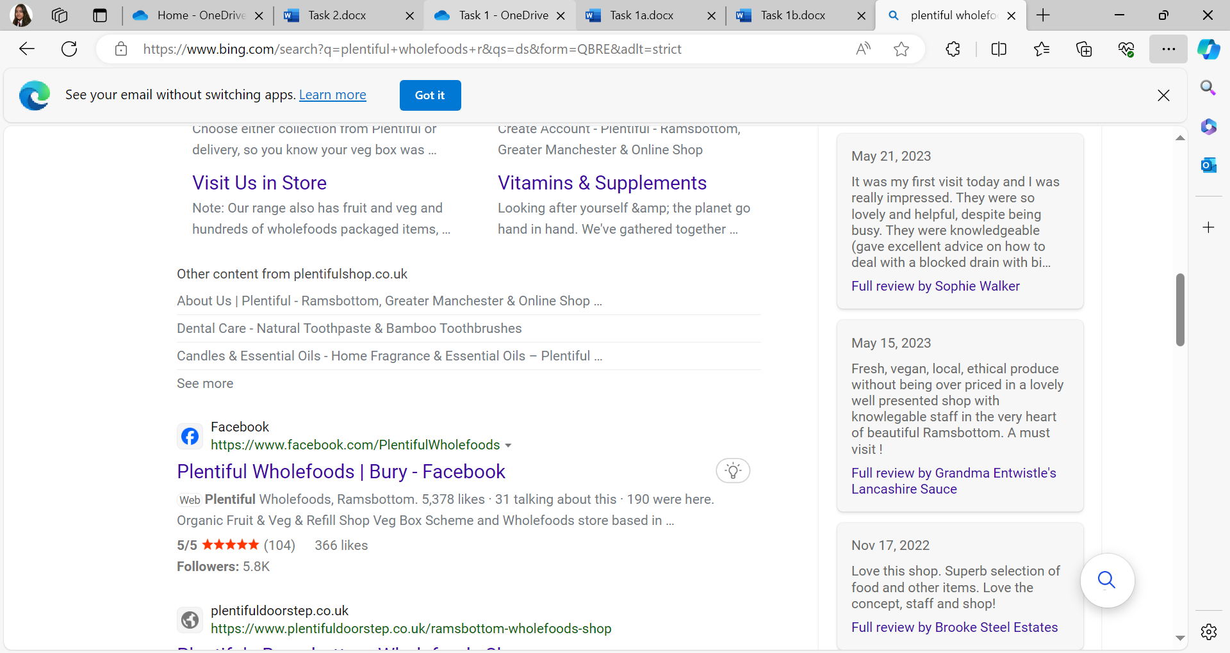 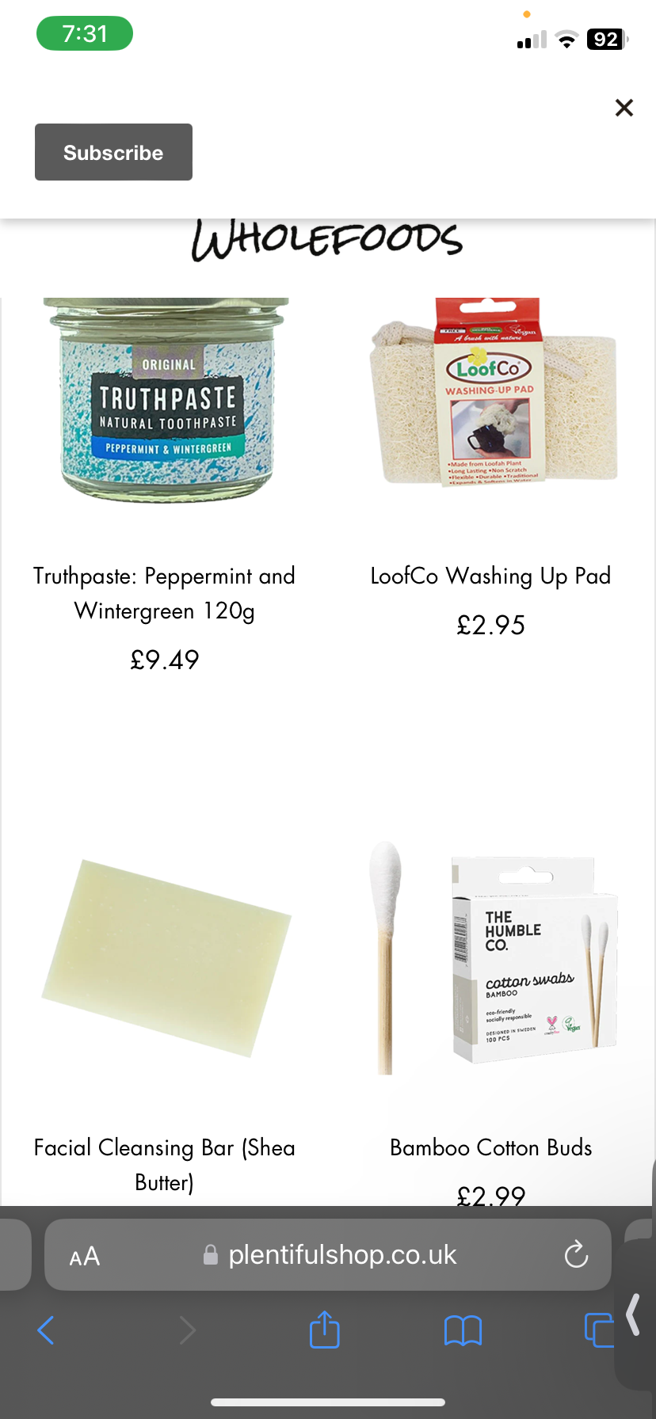
Recommendations
However, I believe that Nigel Evan’s could have chosen alternative methods of research as well. Below I have identified a primary and secondary research method which I think could be useful in gathering information about the customer's needs and competitor's behaviour.
A research method I believe Nigel Evan’s could have used is visit/observations, which is a primary method. This is when you go to your competitors and observe how they run their business and take ideas and possibly use those ideas for your business. Nigel Evan’s could have done this as it's like a questionnaire except you can physically see how the service is offered, what the customers want, the specific prices of products etc. Information that Nigel Evan’s would gather about the customer needs if he used this method is by when he goes to his competitors, for e.g. plentiful wholefoods, he can see the service the competitors offer to their customers and can see if the customers are satisfied, and when he gets ideas about the type of service plentiful wholefoods offer, Nigel Evans can then find out what he can and can’t do when running his business just by observing how the customers react to the service offered to them. Information that Nigel Evan’s would gather about competitor’s behavior if he used this method is prices and offering a service. Nigel Evan’s could have done this by going to his competitors which is plentiful wholefoods and looking at where plentiful whole foods set up their prices at and can see if customers are happy with that and the service the offered to them. This would have then given Nigel Evan’s ideas on how to start up his business as he would have known about the customer's needs and competitors' behavior and know exactly what he can and can’t do. In summary, using this primary method would have had a positive impact on Nigel Evan’s business because it would have helped him understand clearly what satisfies his customers, which would help him meet his aims of satisfying customers. This primary method would have also helped him know where to set his prices at, after looking at where his competitor (plentiful wholefoods) set their prices at, which helped make their business successful as it satisfied customers and if this satisfied plentiful wholefoods customers, this information would have then helped Nigel Evan’s set his prices at a decent price which would also satisfy customers like it does at plentiful wholefoods.
Another research method I believe Nigel Evan’s could have used is tangible items like books, magazines and journals, which is a secondary method. Nigel Evan’s could have used this method because he could find out precise information about businesses like his, who sell wholefoods and eco goods and get more knowledge on how to run his business. Information that Nigel Evan’s would gather about the customer’s needs is what customers look for in a business like his; selling wholefoods and eco goods. This would help Nigel Evan’s a lot as those books, magazines, journals and more, could be written and said by people from experience of running a business who sell wholefoods and eco goods as well. This will let Nigel Evan’s know what to do by looking at what others experienced when running a similar business and if he did this, it could’ve helped him further in making a successful running business; offering a service that customers are satisfied with, making a profit, making a change in the environment by being environmentally friendly etc. This could have also helped Nigel Evan’s meeting his aims as the knowledge from using this secondary method, could have helped him understand how to run his business well, allowing him to meet his aims whilst doing so. Information Nigel Evan’s would gather about the competitor's behavior is that his competitors could have visually put up their brochure and the prices of the products, where and how to buy their products and more, in that brochure. This could have helped Nigel Evan’s as he would get information of how his competitors such as plentiful wholefoods, present their business and their products which could help him in running his business in many ways like knowing where to set his prices at, what products to sell etc. In summary, using this secondary method would have had a positive impact on Nigel Evan’s business because it would’ve helped him understand clearly what customers look for in a business like his of selling wholefoods and eco goods, which means it would have helped him understand what products and service to offer to his customers. This would have then also helped Nigel Evan’s meet his aims of satisfying customers and even making a profit if the customers liked Nigel’s products, which would have led him to selling a lot of them, helping him make a profit. This secondary method would have also helped Nigel Evan’s understand how competitors like plentiful wholefoods, present their business which helped make their business successful and then could have used that information on how they presented their business and products in that brochure, to make a positive impact on his business by knowing how to present his business and products to keep his business successful and running like competitors with similar businesses; plentiful wholefoods.

